# Definitions for all possible Q1 concepts

• Acceptance Testing

Acceptance tests define precisely what it is that the client wants the system to be able to do in order for it to be acceptable. They are black box tests, done both by the client and our independent test team. Acceptance tests are the user’s tests associated with particular requirements.

• Adaptor Pattern

Adapter is a structural design pattern that allows objects with incompatible interfaces to collaborate. An adapter is a special object that converts the interface of one object so that another object can understand it; wraps one of the objects to hide the complexity of conversion happening behind the scenes. The wrapped object isn’t even aware of the adapter.

• Association Relationship

A ‘has a’ relationship, where an object is a part of another, e.g., A Car has an Engine and a Wheel.

• Aggregation Relationship

Aggregation implies an association relationship where the child can exist independently of the parent (every object has its own lifecycle).

• Agile Development

The agile process is a fail early process that involves the client as part of the development team. It can be characterised as providing incremental business value using horizontal and vertical slicing to deliver functionality. By involving the client at all stages of the process rarely are systems delivered that are not fit for purpose. By using an incremental process it may be that systems become hard to maintain.

• Architectural Pattern

An Architectural Pattern expresses a fundamental structural organization or schema for software systems. It provides a set of predefined subsystems, specifies their responsibilities, and includes rules and guidelines for organizing the relationships between them.

• Back-Porting

Backporting is the action of taking parts from a newer version of a software system or software component and adding them to an older version of the same software. It forms part of the maintenance step in a software development process, and it is commonly used for fixing security issues in older versions of the software. Cherry-picks are normally used in this context.

• Behavioural Pattern

Behavioural design patterns are concerned with algorithms and the assignment of responsibilities between objects, as well as how to communicate between them.

• Beta Testing

Beta testing is the final round of testing before releasing a product to a wide audience. Beta testers are “real” users and conduct their testing in a production environment running on the same hardware, networks, etc., as the final release. Beta tests can either be open or closed (set of people).

• Black Box Testing

Black-box testing is a method of software testing that examines the functionality of an application without peering into its internal structures or workings. This method of test can be applied virtually to every level of software testing: unit, integration, system and acceptance.

• Bottom Up Integration Testing

Bottom up integration involves writing drivers to test low level functions in the hierarchy. Only when these are tested, can they be integrated and the next level up of software is tested. Integration testing is done by the developers. It is black box testing.

• Bridge Pattern

Bridge is a structural design pattern that lets you split a large class or a set of closely related classes into two separate hierarchies—abstraction and implementation—which can be developed independently of each other. E.g., instead of having RedCircle, BlueCircle, RedSquare, etc., classes that extend a Shape class, have a Shape class for Circle, Square, etc. and a separate Color class, that is used in Shape, for Red, Blue, etc.

• Candidate Release Branch

Creating this branch starts the next release cycle, so no new features can be added after this point—only bug fixes, documentation generation, and other release-oriented tasks should go in this branch. Once it's ready to ship, the release branch gets merged into main and tagged with a version number. In addition, it should be merged back into the development branches, which may have progressed since the release was initiated.

Using a dedicated branch to prepare releases makes it possible for one team to polish the current release while another team continues working on features for the next release. It also creates well-defined phases of development and helps with maintenance, e.g., by allowing clear cherry-picking.

• Capacity Testing

Similar to stress testing in that it tests traffic loads based on the number of users but differs in the amount. Capacity testing looks at whether a software application or environment can handle the amount of traffic it was specifically designed to handle.

• Checkstyle

A development tool to help programmers write code that adheres to a coding standard. It automates the process of checking code to spare humans of this boring (but important) task. This makes it ideal for projects that want to enforce a coding standard. Checkstyle is highly configurable and can be made to support almost any coding standard.

• Cherry Pick Merge

Given one or more existing commits, apply the change each one introduces, recording a new commit for each. Normally used to apply a single specific commit from one branch on another, e.g., a bug fix.

• CLOC Measure

Commented lines of code; a software metric used to measure the size of a computer program by counting the number of lines in the text of the program's source code. CLOC is typically used to predict the amount of effort that will be required to develop a program, as well as to estimate programming productivity and / or maintainability once the software is produced. (as opposed to NCLOC)

• Code Complexity

Code complexity is the extent to which a software program or system is challenging to understand, maintain, and modify. It measures how hard it is to understand a program's logic, structure, and organization and how much effort is required to make changes. Code complexity can arise from many factors, including the size of the codebase, the number of modules and dependencies, the depth of nesting and inheritance, and the use of complex algorithms and data structures.

• Code Release / Release Tag

Releases are deployable software iterations you can package and make available for a wider audience to download and use. Releases are based on Git tags, which mark a specific point in your repository's history (a pointer to a specific commit).

• Code Reliability

Code reliability measures the expected time to failure of a piece of code. As such it is usually estimated rather than known. Failures are caused by faults or by user error. Hence reliability can be a function of software usability as much as its correctness.

• Code Smells

A code smell is any characteristic in the source code of a program that possibly indicates a deeper problem. Determining what is and is not a code smell is subjective, and varies by language, developer, and development methodology. Categories include Bloaters, Object-orientation abusers, Change preventers, Dispensables, and Couplers.

• Cohesion

Cohesion is the extent to which all methods in a class are related. A highly cohesive class is good as the class then represents a single concept. Cohesive classes are easier to understand, modify and test. They are also much more likely to be reused.

• Composition Relationship

An association relationship where the child cannot exist independent of the parent. Example: House (parent) and Room (child). Rooms don't exist separate to a House.

• Configuration Testing

A software testing technique in which the software application is tested with multiple combinations of software and hardware in order to evaluate the functional requirements and find out optimal configurations under which the software application works without any defects or flaws. E.g., finding if your app can run on only the latest 2 versions of Windows or with all versions as long as you have 8GB of RAM.

• Control Flow Graph

A control-flow graph (CFG) is a representation, using graph notation, of all paths that might be traversed through a program during its execution. The CFG is essential to many compiler optimizations and static-analysis tools, e.g., code coverage reports.

• Corridor Testing

A technique used to evaluate a product by testing it on users. This can be seen as an irreplaceable usability practice, since it gives direct input on how real users use the system. It is more concerned with the design intuitiveness of the product and tested with users who have no prior exposure to it.

• Coupling

Coupling is the degree to which different classes are associated. Low coupling is good as it means that there is a degree of independence between classes. Independent classes are easier to test and reuse.

• Creational Design Pattern

Creational design patterns provide various object creation mechanisms, which increase flexibility and reuse of existing code. Trying to create objects in a manner suitable to the situation.

• Dead Code Smell

A dispensable code smell. Occurs when a variable, parameter, field, method or class is no longer used (usually because it’s obsolete), e.g., when requirements for the software have changed or corrections have been made and nobody had time to clean up the old code. Such code could be found in complex conditionals, when one of the branches becomes unreachable (due to error or other circumstances).

• Delegation

Allows object composition to achieve the same code reuse as inheritance. In delegation, an object handles a request by delegating to a second object (the delegate). The delegate is a helper object, but with the original context. E.g. NumStack delegates to Stack in calculator coursework. ‘Getting another class to do the work for you’.

• Design Patterns

A Design pattern is a commonly occurring solution to a software design problem. Design patterns characterise the problem to be solved in words and also consist of a standard implementation.

• Double Dispatch

A mechanism that dispatches a function call to different concrete functions depending on the runtime types of two objects involved in the call. Implemented by, for e.g., overriding a method from an interface in multiple different classes & using an overloaded method in a Visitor to be visited by the overridden methods.

• Facade Pattern

Facade is a structural design pattern that provides a simplified interface to a library, a framework, or any other complex set of classes.

• Factory Pattern

Factory Method is a creational design pattern that provides an interface for creating objects in a superclass, but allows subclasses to alter the type of objects that will be created. E.g., a factory for creating a calculator, where the subclasses can decide on which type (infix, postfix, octal, etc.), based on the environment.

• Feature Branch

Feature development should take place in a dedicated branch instead of the main branch. This encapsulation makes it easy for multiple developers to work on a particular feature without disturbing the main codebase. It also means the main branch will never contain broken code, which is a huge advantage for continuous integration environments.

• Feature Envy

A coupler code smell; a method accesses the data of another object more than its own data. This smell may occur after fields are moved to a data class. If this is the case, you may want to move the operations on data to this class as well.

• Functional Testing

Functional testing is a quality assurance (QA) process and a type of black-box testing that bases its test cases on the specifications and requirements of the software component under test.

• Git add

Adds a change in the working directory to the staging area. It tells Git that you want to include updates to a particular file in the next commit.

• Git branch

Git branches are effectively a pointer to a snapshot of your changes. When you want to add a new feature or fix a bug—no matter how big or how small—you spawn a new branch to encapsulate your changes in an isolated environment. This makes it harder for unstable code to get merged into the main code base, and it gives you the chance to clean up your future's history before merging it into the main branch.

• Git clone

If a project has already been set up in a central repository, the git clone command is the most common way for users to obtain a development copy. Like git init, cloning is generally a one-time operation. Once a developer has obtained a working copy, all version control operations and collaborations are managed through their local repository.

• Git commit

The git commit command captures a snapshot of the project's currently staged changes. Committed snapshots can be thought of as “safe” versions of a project—Git will never change them unless you explicitly ask it to.

• Git Conflict

Conflicts generally arise when two people have changed the same lines in a file, or if one developer deleted a file while another developer was modifying it. In these cases, Git cannot automatically determine what is correct in a merge. Conflicts only affect the developer conducting the merge, the rest of the team is unaware of the conflict. Git will mark the file as being conflicted and halt the merging process. It is then the developers' responsibility to resolve the conflict.

• Git index (Staging Area)

The Git index is a staging area between the working directory and repository. It is used to build up a set of changes that you want to commit together.

• Git log

The git log command displays a record of the commits in a Git repository. By default, the git log command displays a commit hash, the commit message, and other commit metadata. You can filter the output of git log using various options, e.g., git lola uses log to output a git graph with certain details.

• Git merge

Merging is Git's way of putting a forked history back together again. The git merge command lets you take the independent lines of development created by git branch and integrate them into a single branch. Git merge will combine multiple sequences of commits into one unified history.

• Git push, pull

The git push command is used to upload local repository content to a remote repository. It's the counterpart to git fetch, but whereas fetching imports remote commit information to local branches, pushing exports commits to remote branches. The git pull command is used to download content from a remote repository and immediately update the local repository to match that content.

• Git remote

The git remote command lets you create, view, and delete connections to other repositories. Remote connections are more like bookmarks rather than direct links into other repositories. Instead of providing real-time access to another repository, they serve as convenient names that can be used to reference a not-so-convenient URL.

• Git revert, reset

Git revert creates a new commit; the inverse of the referenced commit, essentially reverting it (deleting what was added and adding back what was removed). Does not modify history. Git reset modifies the git history, rewinding it to, for e.g., delete a commit

• Git rm

Deletes a file from git’s index / tracking information – modifies repository history. E.g., ‘git rm aFile.txt’ removes it from every commit and makes it untracked.

• Git Tracked/Untracked

Tracked files are files that Git is aware of and actively manages. These are files that have been added to the Git repository using the git add command and committed with git commit. Untracked files are files that are not currently being managed by Git. These are typically files that exist in the working directory of your repository but have not been added to the Git repository using git add. Untracked files will not be included in commits.

• Git: HEAD, ∼ and ˆ

The HEAD in Git is the pointer to the current branch reference, which is in turn a pointer to the last commit you made on the branch. ~ refers to ancestors of a referenced commit. Ancestors are direct parents, whole levels of hierarchy above. ^ refers to parents of a referenced commit. E.g., HEAD~1 == HEAD^1, HEAD~2 == HEAD^^, but there is no way to access HEAD^2 via ~ since ^2 is not a direct parent; HEAD~1^2 == HEAD^1^2

• Good Code

Good Code is Readable and Works. Programming standards make code more easily readable. TDD can ensure it works.

• Horizontal Slice

Horizontal slicing emphasizes building separate layers or components of a system incrementally. Each iteration focuses on adding specific functionality across the entire system rather than delivering a complete end-to-end feature. This technique often involves building or enhancing underlying infrastructure or architectural components before moving on to subsequent layers.

• IDE

An integrated development environment (IDE) is a software application that provides comprehensive facilities for software development. An IDE normally consists of at least a source-code editor, build automation tools, and a debugger. It increases developer productivity by combining capabilities such as software editing, building, testing, and packaging in an easy-to-use application.

• Incremental Business Value

Agile processes focuses on delivering Business Value; a viewpoint that allows people with different perspectives to understand each other and identify what really matters to the product. For organizations, what matters is usually the value that brings economic profits. Bringing this incrementally means giving it in small chunks over time, instead of once, right at the end.

• Incremental Delivery

A team delivers work frequently rather than all at once.  Incremental means that they deliver it in small packets of end-to-end functionality which is usable.  Afterall, the only thing better than a great product is a great product that gets better frequently.

• Indirect Measure

Indirect measurement of an attribute is measurement which involves the measurements of one or more other attributes.

• Integration Testing

Usually done in a black-box approach, testing functionality after separate components of a piece of software have been linked / merged together.

• IPSE

A Integrated Project Support Environment is an IDE dedicated to a specific type(s) of project.

• Javadoc

Javadoc is a documentation generator created for the Java language for generating API documentation in HTML format from Java source code. The HTML format is used for the convenience of access to different parts through links.

• Junit/Junit Test

JUnit is a unit testing framework for the Java programming language, often used for TDD.

• Literate Programming

A paradigm where code becomes documentation. Code is written in a way that can be understood as if it were a natural language. E.g., “if (condition) result = true else false” instead of “result = condition ? true : false”

• Major Release

A major release introduces wide-ranging changes to the existing software version, including new features to improve the user experience.

• Metrics

A standard of measure of a degree to which a software system possesses some property. Metrics are functions, while measurements are the numbers obtained by the application of metrics. Help to ensure an objective will be obtained.

• Minor Release

A minor release introduces small improvements to the software's functionality. However, changes or modifications are made to existing features instead of the release of new key features.

• Mock Objects

Mock objects are simulated objects that mimic the behaviour of real objects in controlled ways, most often as part of a software testing initiative. E.g., a Mock view to mimic how a controller should interact with the real view.

• MVC Pattern

Model–view–controller (MVC) is an architectural software design pattern. Elements are the internal representations of information (the model), the interface (the view) that presents information to and accepts it from the user, and the controller software linking the two.

• Non-incremental Testing

Testing all the units or modules at once, after they have been individually tested and verified. This way, you can save time and resources, avoid redundant testing, and test the system as a whole.

• Observer Pattern

Observer is a behavioural design pattern that lets you define a subscription mechanism to notify multiple objects about any events that happen to the object they’re observing. E.g., notifying a piece of logic that a button has been clicked on, in the UI.

• Once And Only Once Smell

Each and every declaration of behaviour should appear Once and Only Once. Duplicate code removed to ensure simplicity.

• Primitive Obsession

Occurs when you use primitives instead of small objects for simple tasks (such as currency, ranges, special strings for phone numbers, etc.) or use of constants for coding information (such as a constant USER_ADMIN_ROLE = 1 for referring to users with administrator rights). Code becomes more flexible thanks to use of objects instead of primitives. Better understandability and organization of code. Operations on particular data are in the same place, instead of being scattered.

• Programming Standards

Defines how to write literate, working code without smells. Programming standards make code more easily readable. They also make code more likely to work because they remove language faults and common sources of error. Usually enforced using checkstyle.

• Programming Style

A set of rules or guidelines that governs the layout of source code. Programming style may also refer an quality aspect of code that is interpreted subjectively.

• Refactoring

A process of restructuring existing code, without changing its external behaviour. Refactoring is intended to improve the design, structure, and / or implementation of the software.

• Regression Testing

Re-running functional and non-functional tests to ensure that previously developed and tested software still performs as expected after a change. If not, that would be called a regression.

• Reintegration Merge

When the changes made in a branch need to be integrated back into the branch's ancestor.

• Reliability (of Software)

Measures the expected time to failure for software. Helps ensure usability and correctness.

• Revision Control Branches

When a developer creates a branch, the version control system creates a copy of the code base at that point in time. An isolated development environment for a specific purpose. Changes to the branch don't affect others; features under development can create instability, which would be highly disruptive if all work was happening on the main code line.

• Revision Control System

A Revision Control System is a repository that allows versions of files to be stored. Any version of any file can be checked out. Important to the concept is that each commit is tagged with the user’s identity and a comment that describes the changes e.g. RCS can be used to manage code tasks.

• Scrum Sprint

A sprint is a short, time-boxed period when a scrum team works to complete a set amount of work.

• Singleton Pattern

Singleton is a creational design pattern that lets you ensure that a class has only one instance, while providing a global access point to this instance. E.g., A country can have only one official government.

• Slicing

Partitioning a codebase based on points of interest during development.

• Smoke Testing

Preliminary testing or sanity testing to reveal simple failures severe enough to, for example, reject a prospective software release. Smoke tests are a subset of test cases that cover the most important functionality of a component or system, used to aid assessment of whether main functions of the software appear to work correctly.

• Software Failure

A fault may manifest itself as a failure - any departure from required system behaviour. Not all failures are caused by faults.

• Software Fault

An error during software development leads to a defect in the specification or code. If not detected and removed, it may result in a fault in the system during testing. A fault is a defect which has persisted until the code is executable.

• Software Release

A release is the distribution of the final version or the newest version of a software application

• Software Validation

Software validation is the process of evaluating a software system during or at the end of the development process to determine whether it satisfies the intended use and can meet user needs. It answers the question, "Are we building the right software?"

• Software Verification

Software verification is the process of evaluating a software system to determine whether it meets the specified requirements and functions correctly. It focuses on answering the question, "Are we building the software right?"

• Strategy Pattern (State)

Strategy is a behavioural design pattern that lets you define a family of algorithms, put each of them into a separate class, and make their objects interchangeable. E.g., Separating a route finder into route finders for walking, driving, cycling, going by public transport, etc. (different strategies).

• Stress Testing

Stress testing places a system under higher-than-expected traffic loads so developers can see how well the system works above its expected capacity limits.

• Structural Design Pattern

Structural design patterns explain how to assemble objects and classes into larger structures, while keeping these structures flexible and efficient.

• Sync Merge

A merge operation designed to bring your branch up to date with any changes made to its ancestral parent branch.

• System Prototype

A prototype is an early sample, model, or release of a product built to test a concept or process.

• System Testing

System tests are any tests of the whole system in an environment. But also other tests such as conformance, reliability, security etc., which the user would be unlikely to have specified.

• Task

A task specifies a piece of development work that needs to be carried out by one developer in order to construct part of a user story.

• Test Driven Development (TDD)

A software development process relying on software requirements being converted to test cases before software is fully developed, and tracking all software development by repeatedly testing the software against all test cases. RED, GREEN, REFACTOR, COMMIT

• Test Harness

A test harness is a collection of stubs and drivers configured to assist with the testing of an application or component. It acts as imitation infrastructure for test environments where the full infrastructure is either not available or not desired.

• Three Way Merge

The common ancestor of two distinct versions of a file or codebase is used as the base of the merge operation itself.

• Too Few Comments Smell

When comments are needed to explain complex algorithms (when all other methods for simplifying the algorithm have been tried and come up short) as how they work is not obvious at first glance.

• Too Many Comments Smell

Excessive comments for code that tends to already be intuitive and obvious. The best comment is a good name for a method or class (code as documentation).

• Top Down Integration Testing

Top-down integration testing is an integration testing technique used in order to simulate the behaviour of the lower-level modules that are not yet integrated

• Triangulation and Faking

Faking is making code pass tests through making it only satisfy the test requirements and not the actual functional requirements. Triangulation is a specialized form of faking where you take baby-steps in tests, usually as separate tests, to ensure all functional requirements are covered. “Faking is getting something to work! Triangulation is going slowly enough, bit by bit. You develop your own understanding as you develop the final algorithm”

• Two Way Merge

Where a single history of changes is applied to an ancestor, using a diff.

• UML Class Diagram

A UML class diagram is a picture used to describe the kinds of object that will exist in the running system. Not only does each object (class) get reported – with state and responsibilities - but their associations are also depicted using lines between classes. Stereotypes and comments can help us to understand the UML.

• UML Class Relationships

Represent logical connections like association, aggregation, composition, realization, etc.

• UML Sequence Diagram

Shows process interactions arranged in a time sequence. The diagram depicts the processes and objects involved and the sequence of messages exchanged as needed to carry out the functionality.

• Unit Testing

Usually White-box; the testing of individual software units. Testers verify that the code does what it is intended to do. Tests that will call a sequence of methods and check return values. Tests might ensure that both branches of if/else are executed. Scale: Unit testing is generally done within a class or a component.

• Vertical Slice

Vertical slicing involves delivering a complete, end-to-end feature or user story within each development iteration. Each slice includes user interface elements, business logic, and data storage components necessary for the specific feature.

• Visitor Pattern

Visitor is a behavioural design pattern that lets you separate algorithms from the objects on which they operate. E.g., moving a graph traversal algorithm away from a node object.

• Waterfall Development

A sequential development process, not agile, where each phase depends on the deliverables of the previous one and corresponds to a specialization of tasks. Tends to be less interactive, slow to accommodate change in requirements, etc.

• White Box Test

A method of software testing that tests internal structures or workings of an application, to ensure that all the internal components work as expected and are error-free.

## Examples for describing connections between concepts

Here are two examples of how to show how you might describe the connections between concepts.

• Coupling and Cohesion

Coupling and cohesion are both concepts to do with the design of classes. Both allow for simpler testing and reuse. Both make code easier to read. Both are achieved (to some extent) by the application of design patterns. Both are achieved by refactoring - changing code design without changing its functionality.

• System and Acceptance Tests

System tests include acceptance tests but are specified in house rather than by the client. Acceptance tests are about delivery and (mostly) system usefulness (functional tests). Other system tests are concerned with security, scalability rather than just usability. Both System tests and Acceptance tests are run to ensure that the code will work effectively in the client environment. System tests are what we run to make sure that we are happy to deliver the system, whilst acceptance tests are run by the client to make sure that they are happy to accept delivery.

# Other Notes

Software Engineering makes sure that software adds business value in a timely fashion. The processes should fail early and be responsive to customer needs.

Software Engineering is a variety of techniques, processes and tools that allow everyone to write good code as part of a team that works when delivered into the client environment.

Agile Manifesto:

Individuals and interactions over processes and tools

Working software over comprehensive documentation

Customer collaboration over contract negotiation

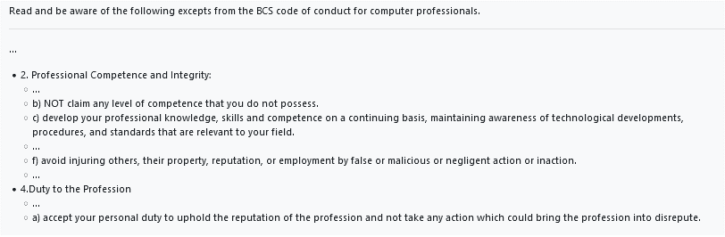Responding to change over following a plan



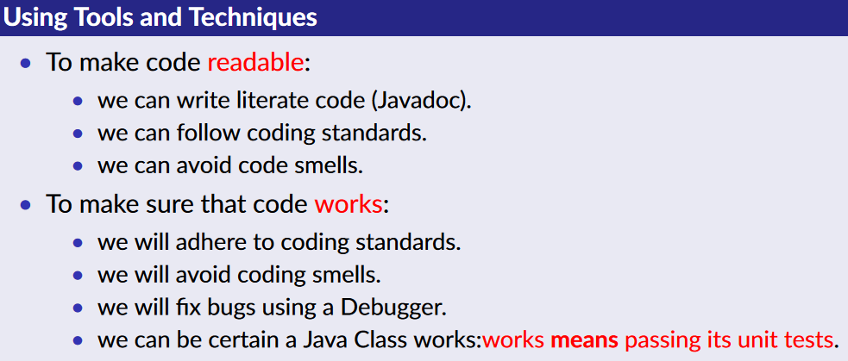

## Techniques

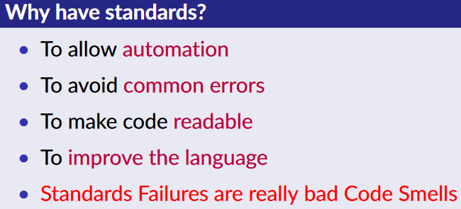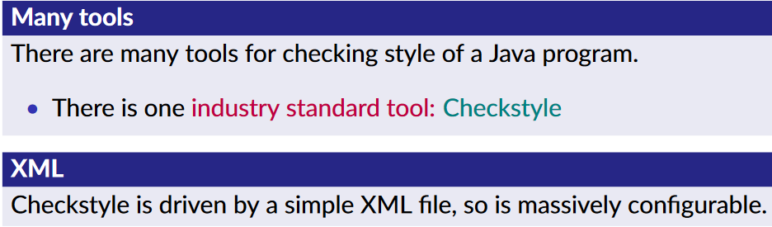Refactoring means to tidy up the code (only to introduce patterns or remove smells) without changing the behaviour of the code at all.

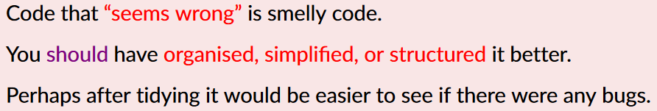Code smells

#### A screenshot of a computer Description automatically generatedThe Once And Only Once (OAOO) smell

#### A blue and white rectangular box with orange text Description automatically generated with medium confidenceThe Long Method Smell





#### A screenshot of a computer Description automatically generatedThe Feature Envy Smell

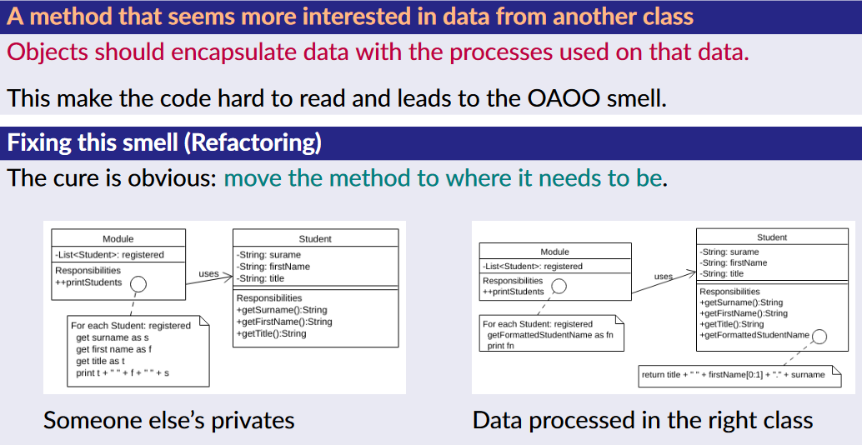







#### A close-up of a computer screen Description automatically generatedToo Many Comments Smell

#### A blue and orange text Description automatically generatedThe Primitive Obsession Smell

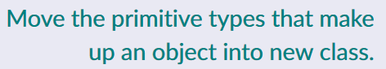

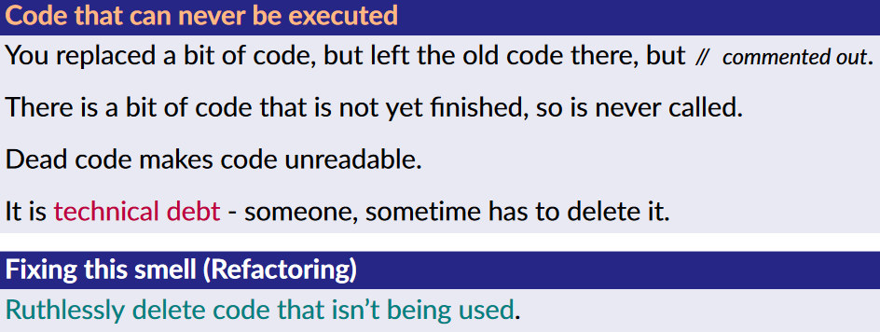

#### The Dead Code Smell

#### Smells that look like Standards

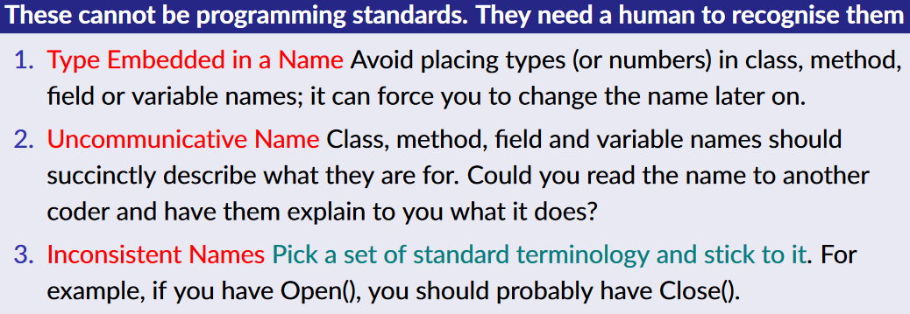

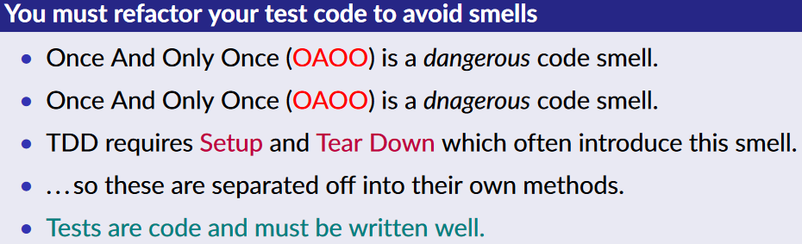

## A page of a computer program Description automatically generatedProcesses

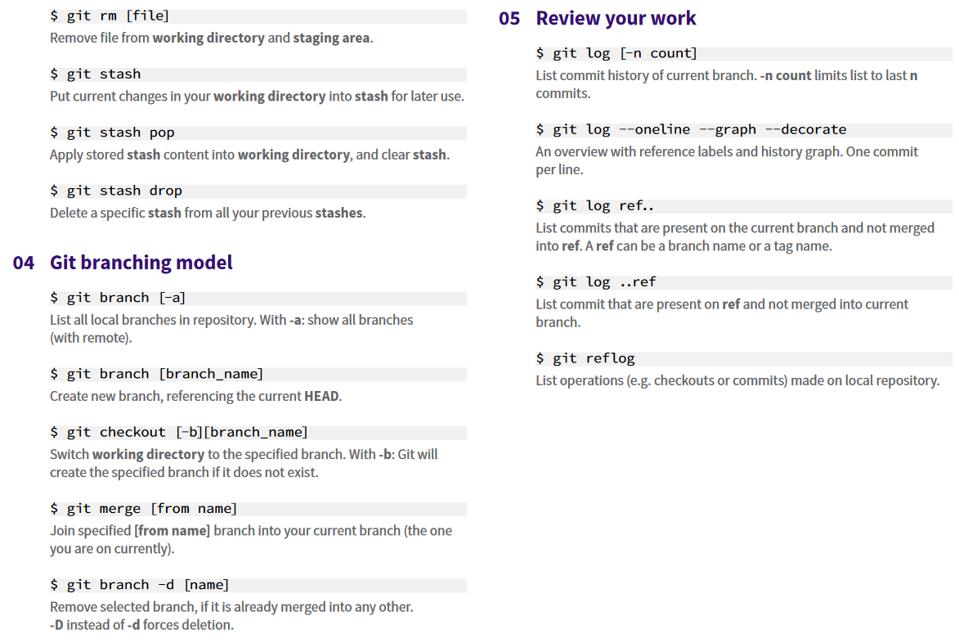





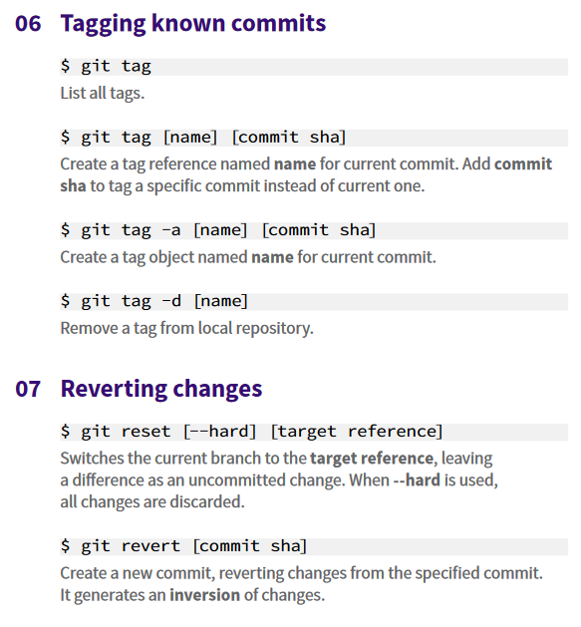

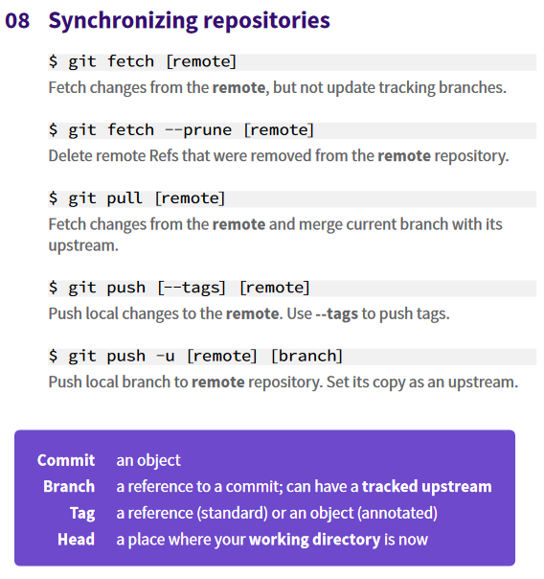

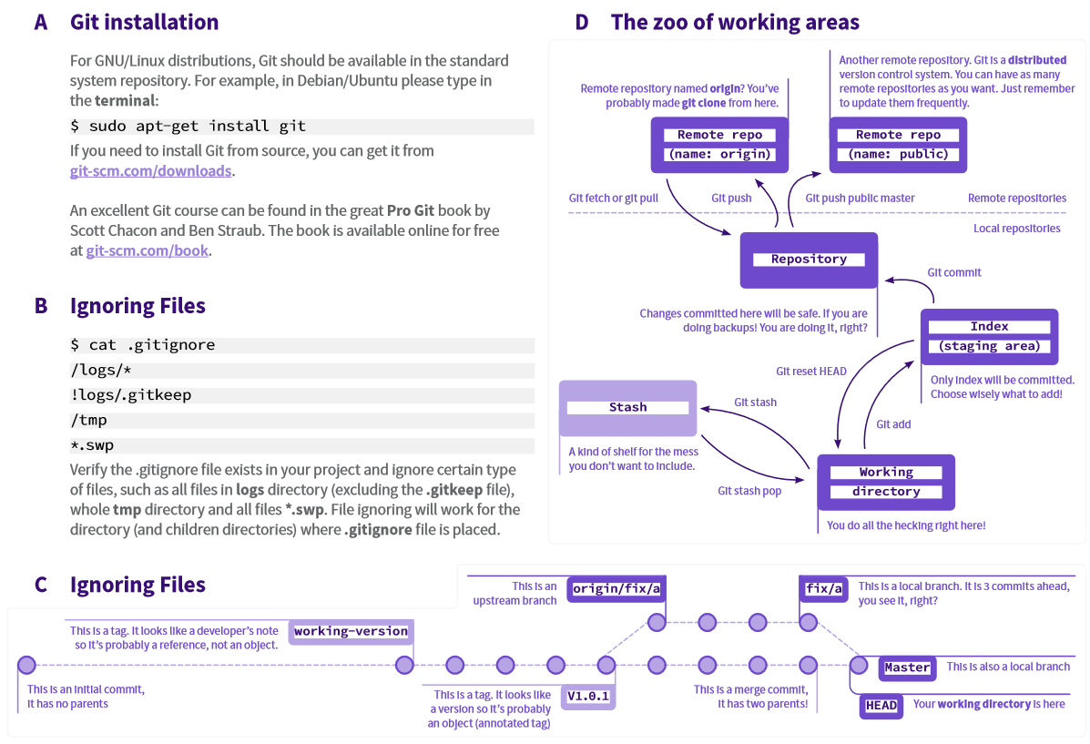

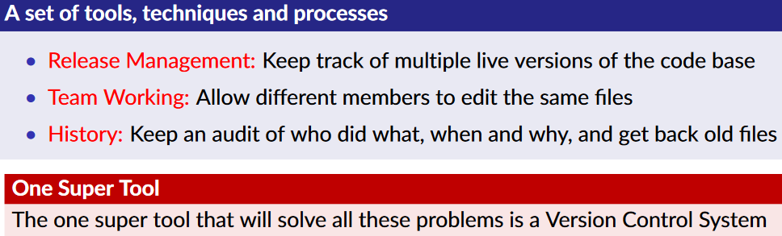

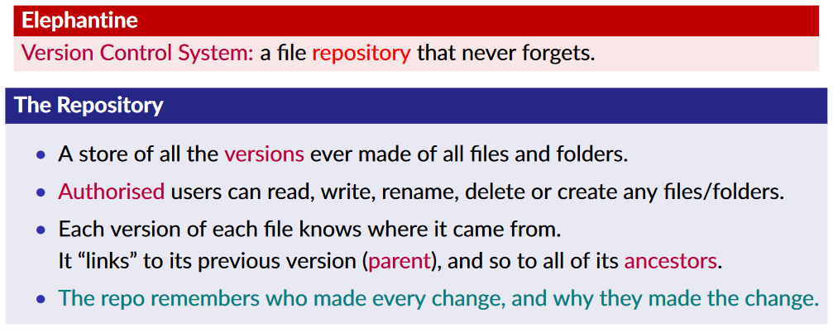

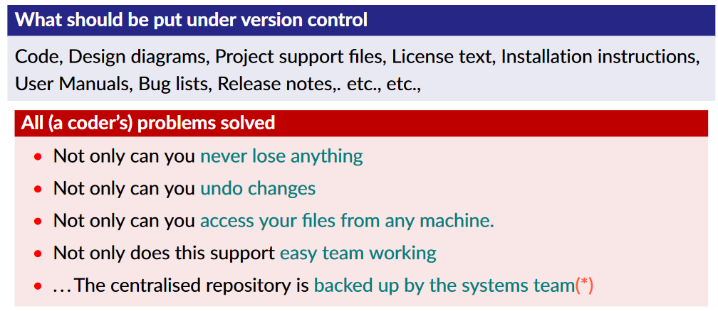

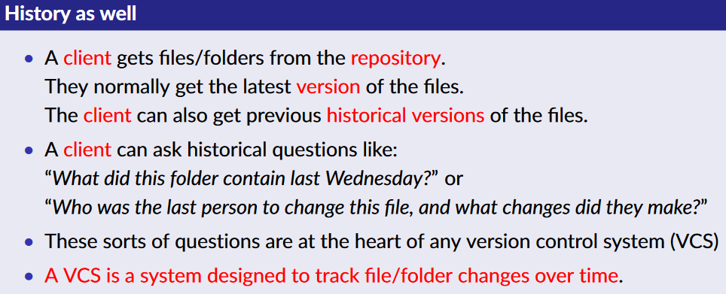





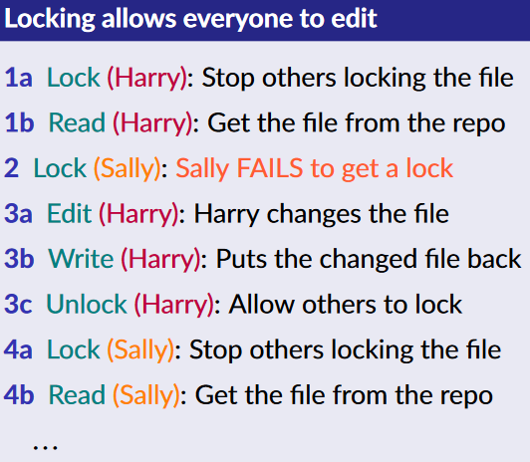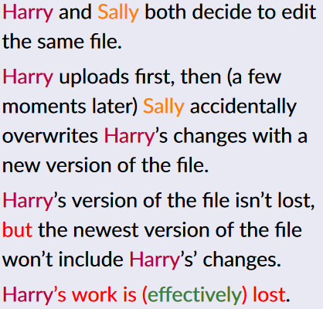

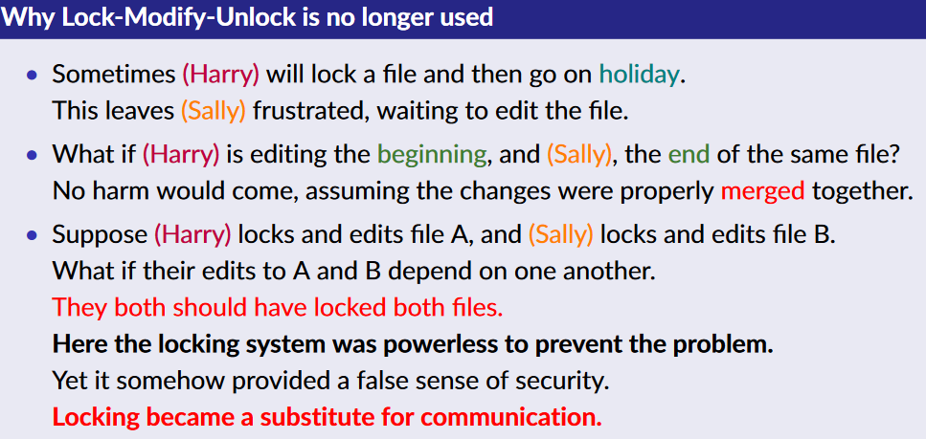

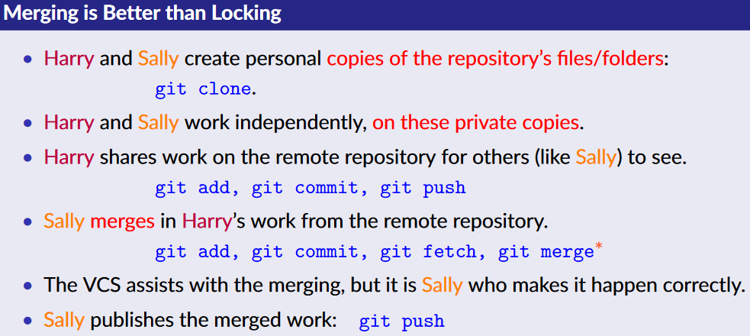

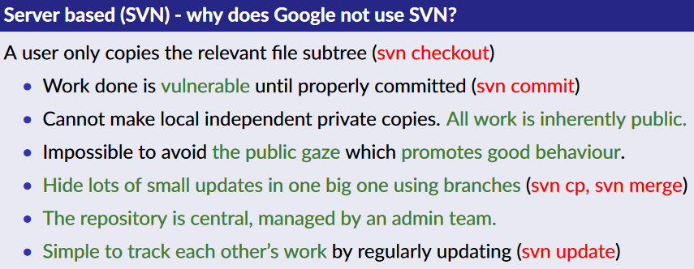

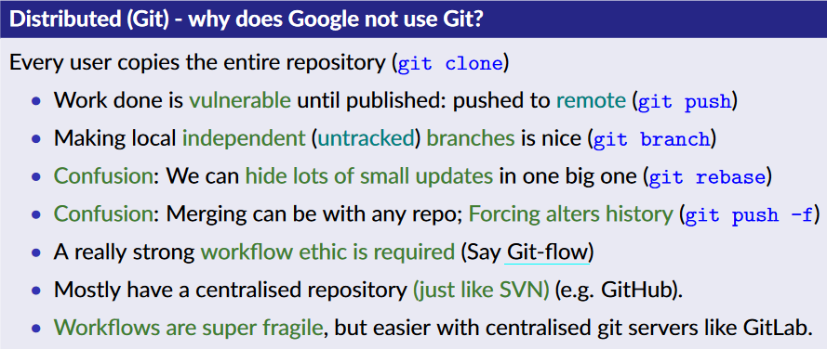



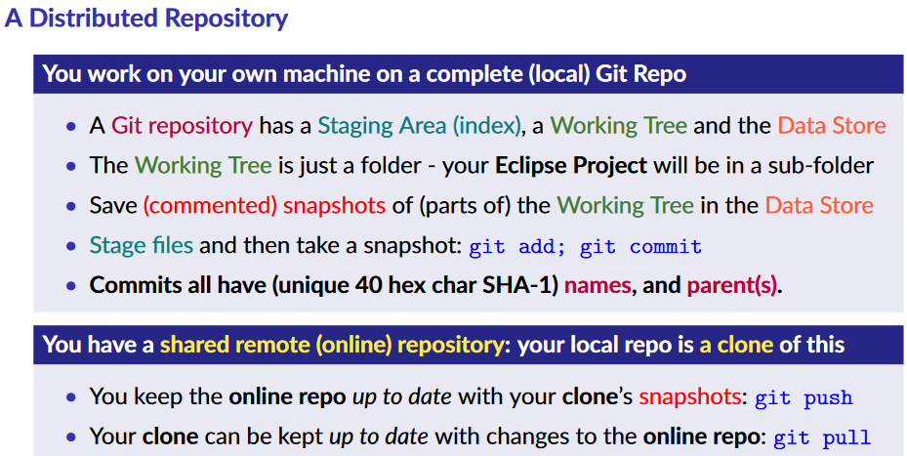

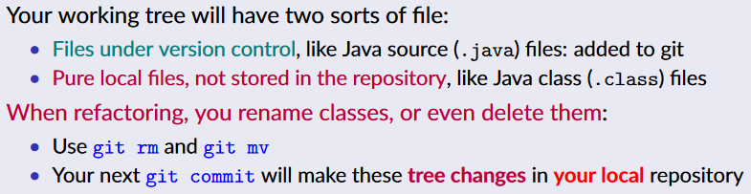

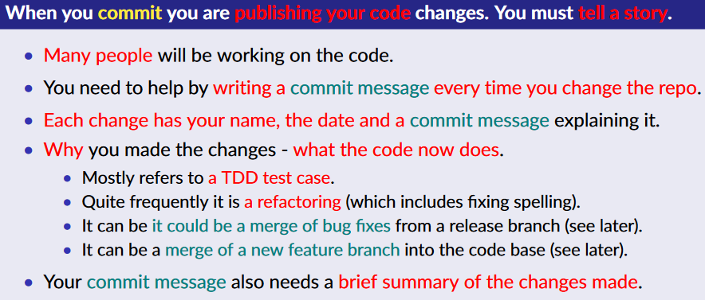

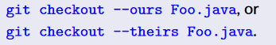

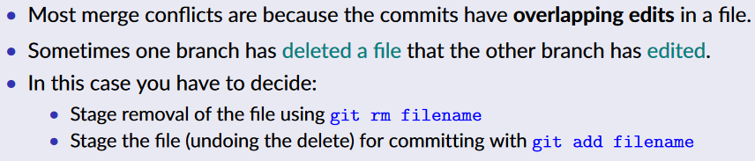

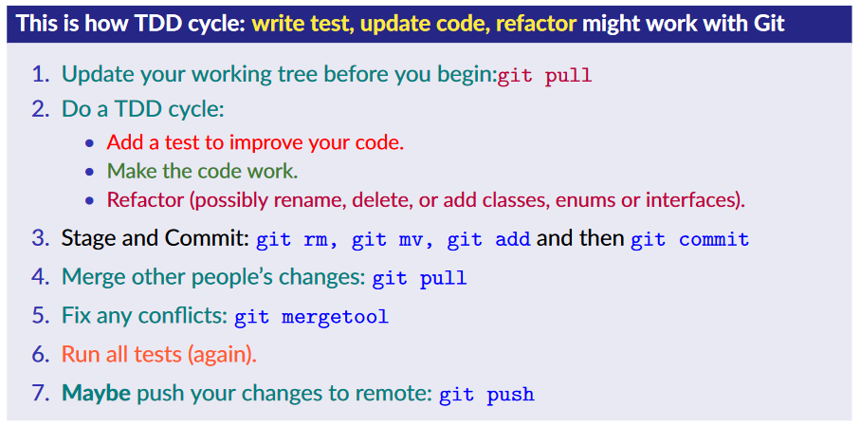

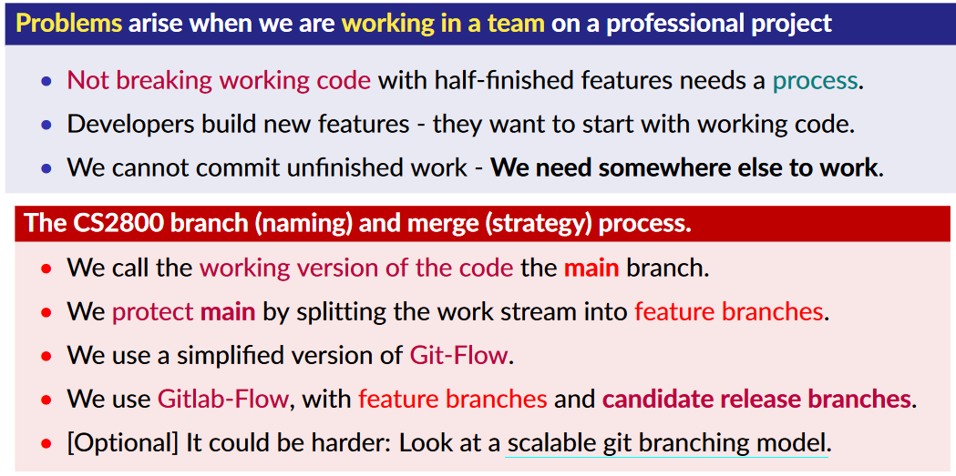

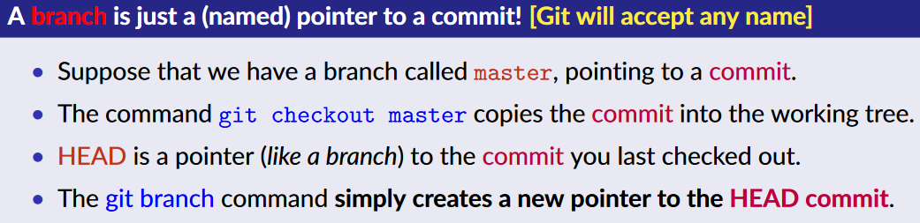

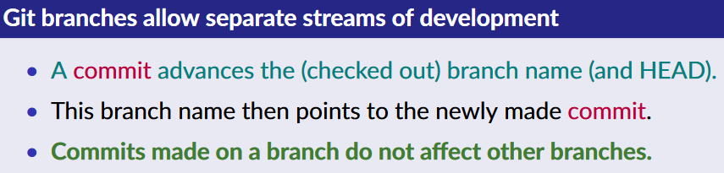

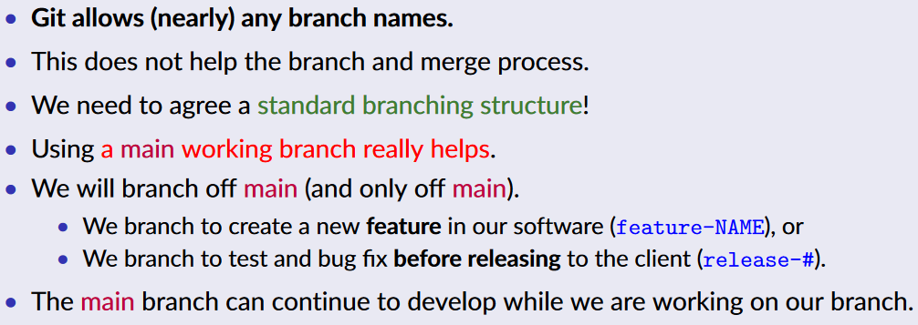

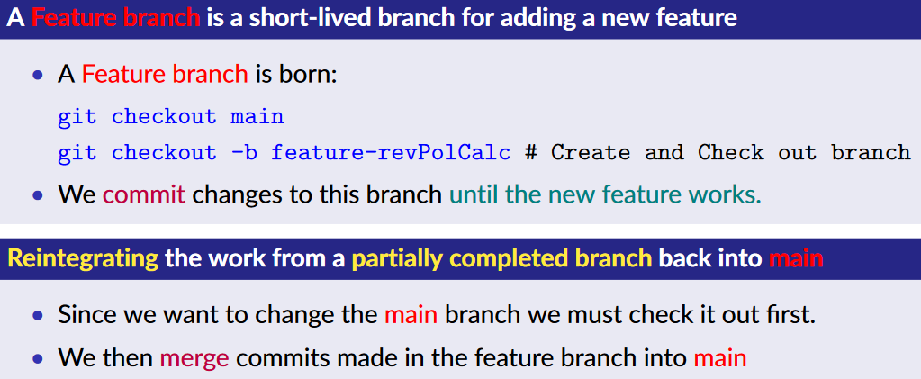

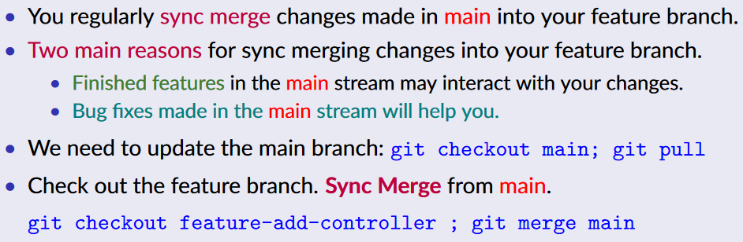

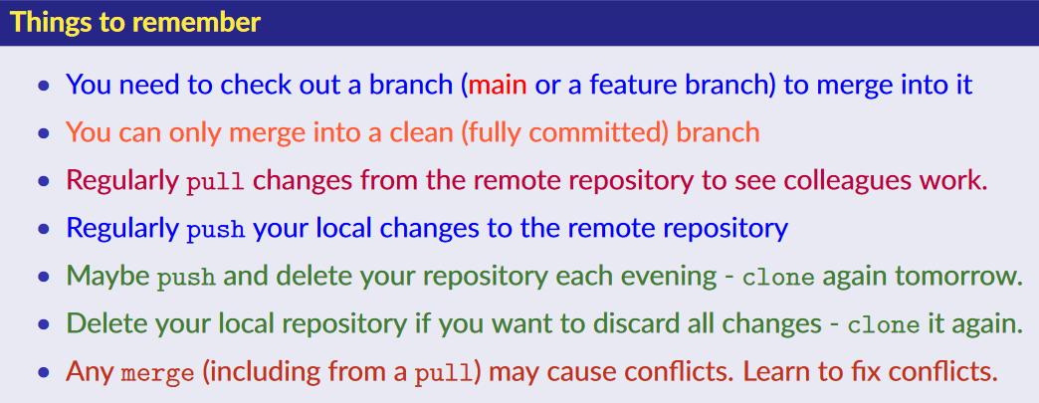

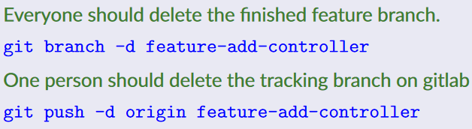

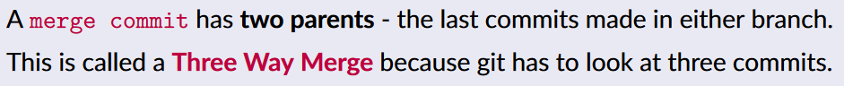

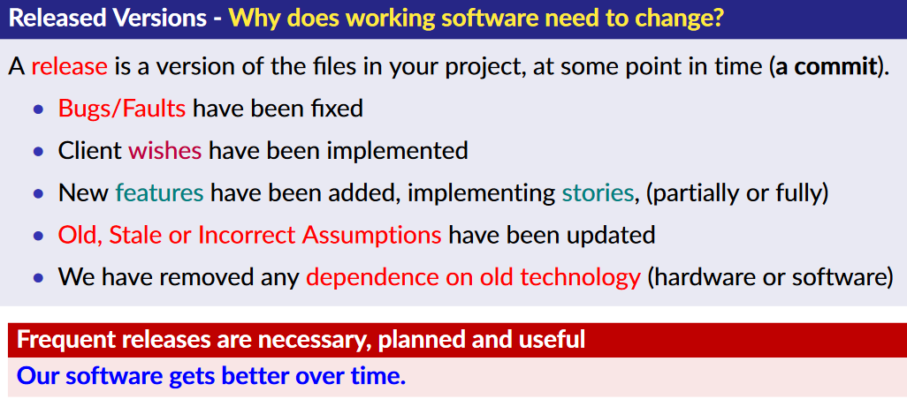

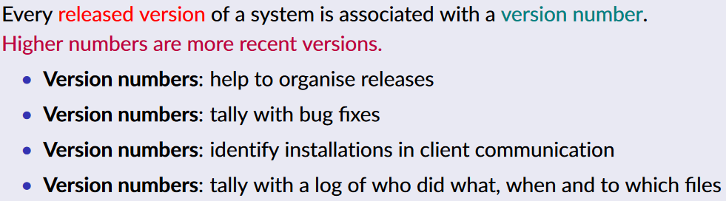

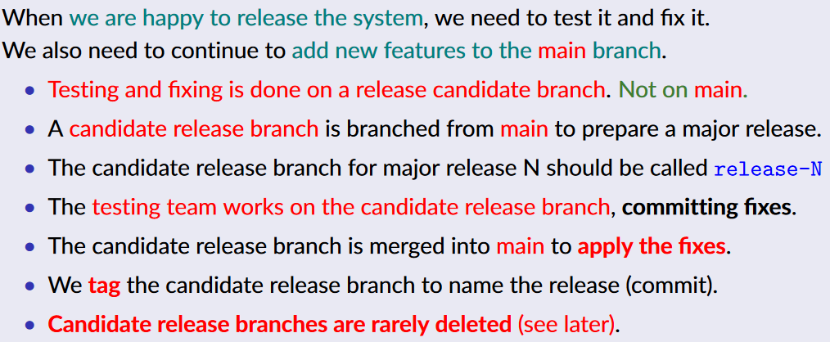

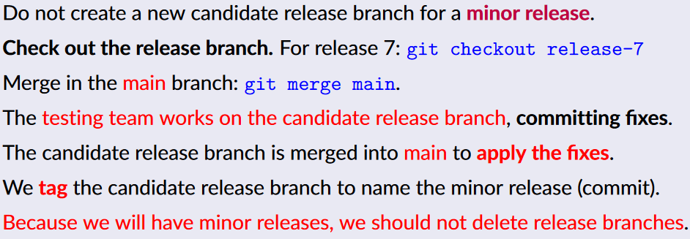

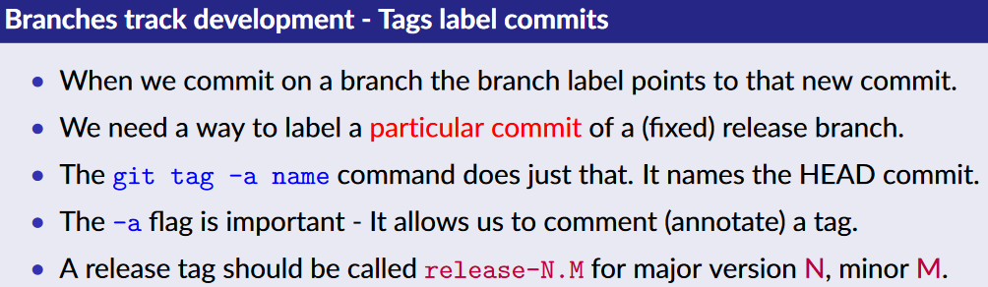



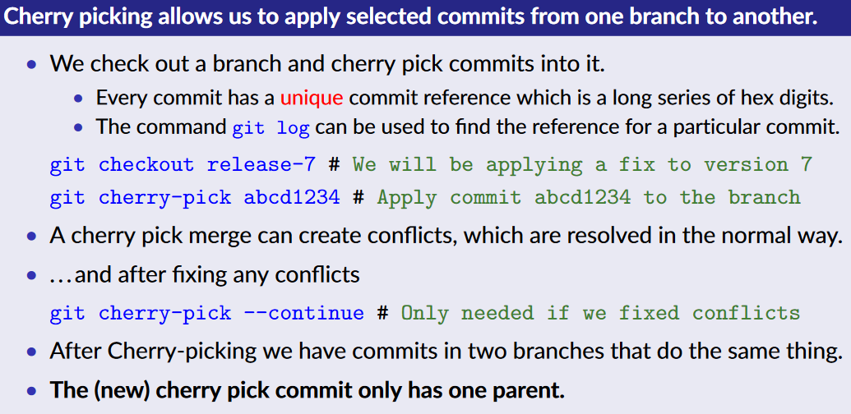

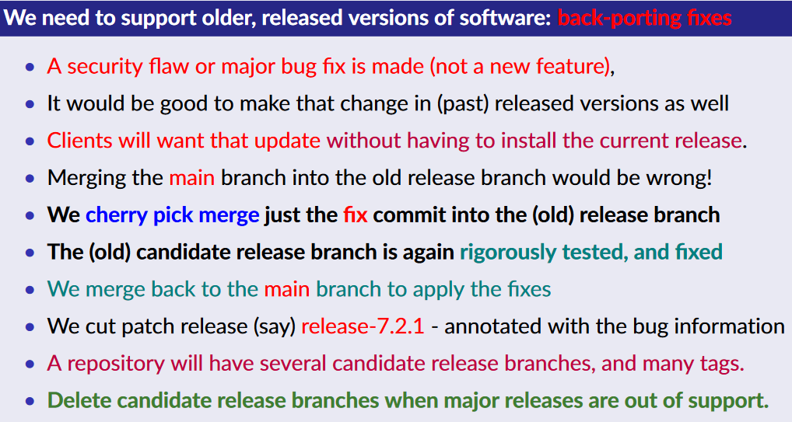

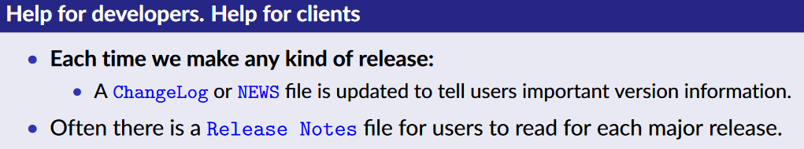

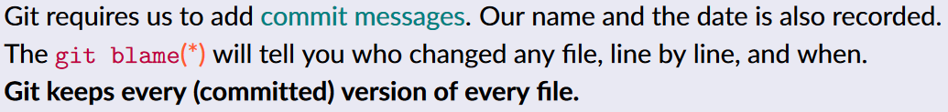

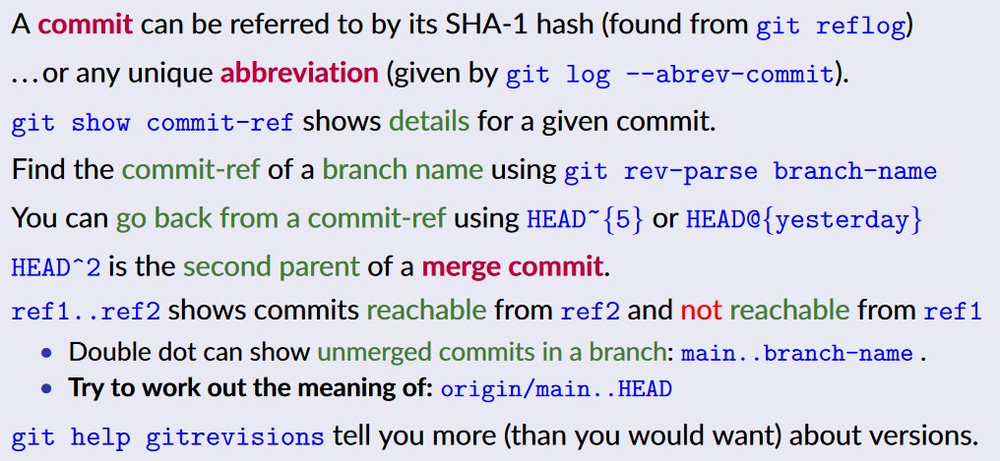



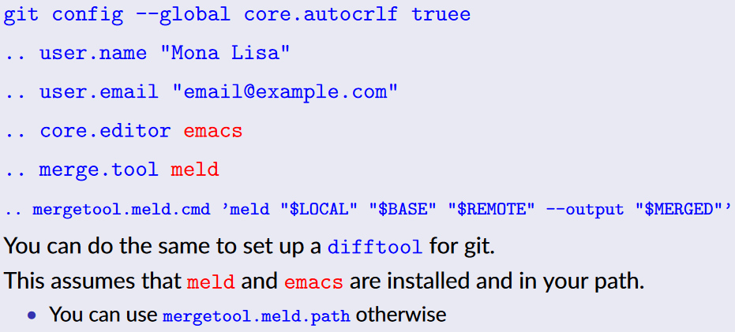

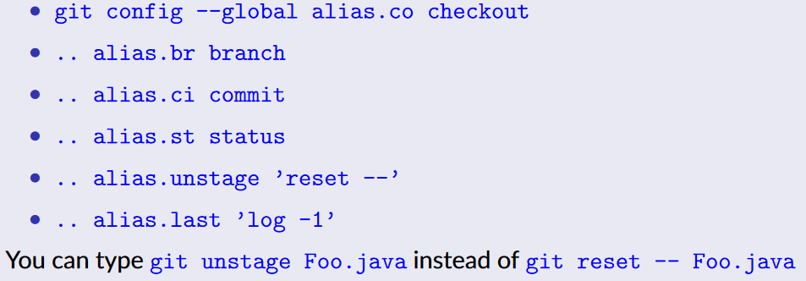

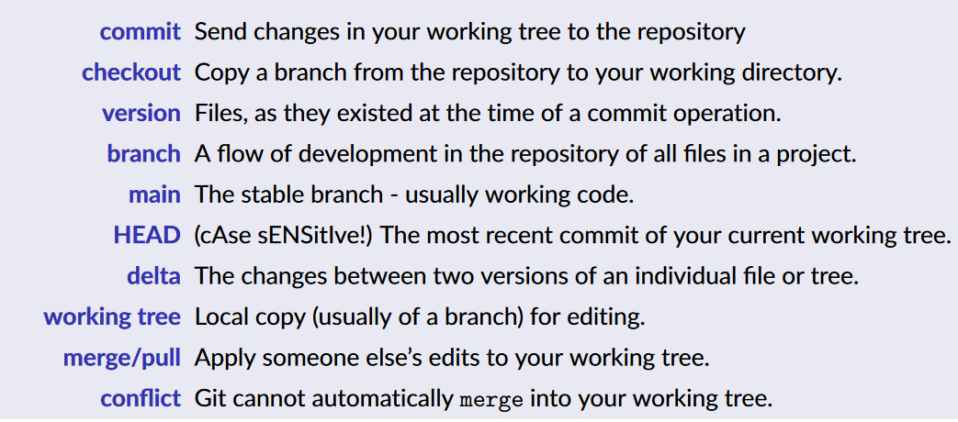

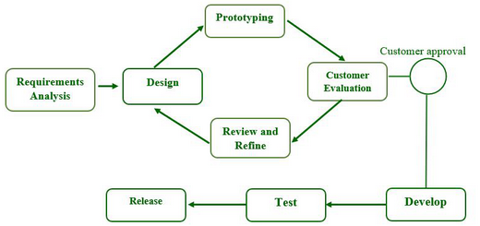



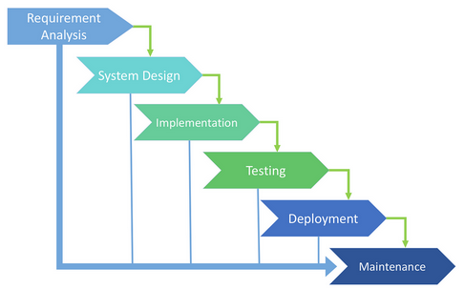

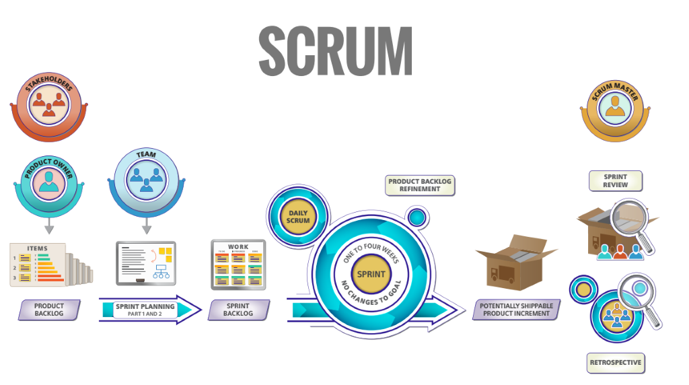

## A screenshot of a computer Description automatically generatedTesting

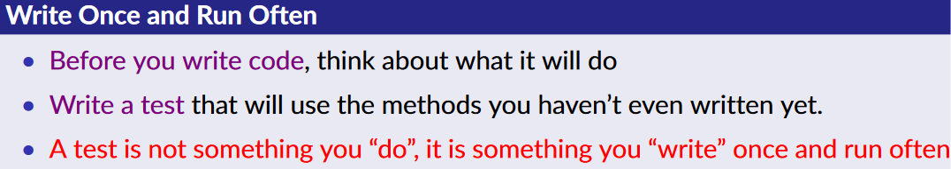

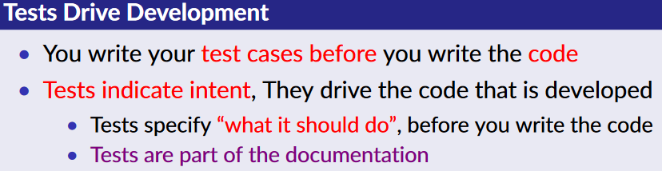

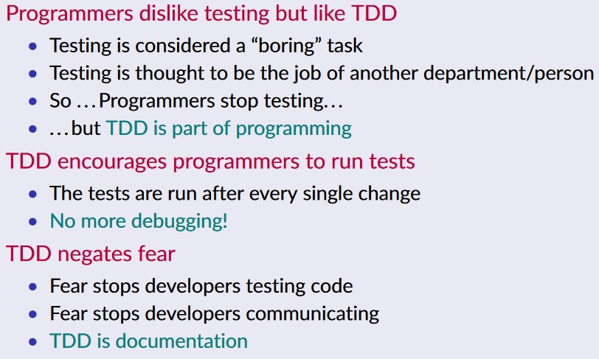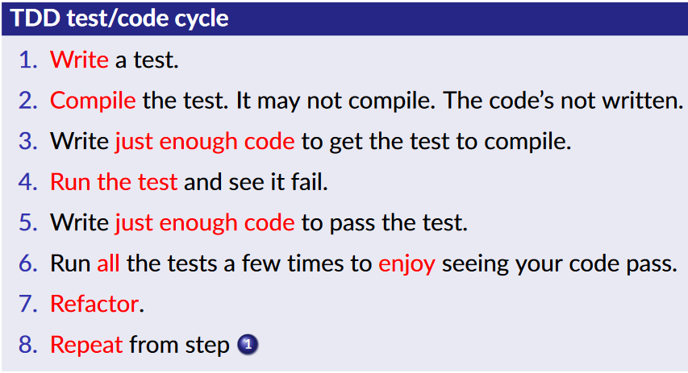

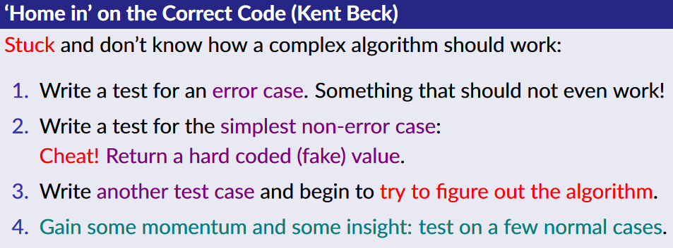

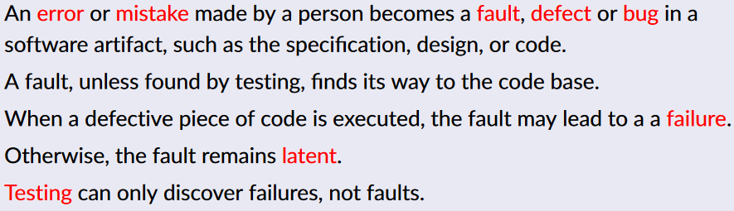

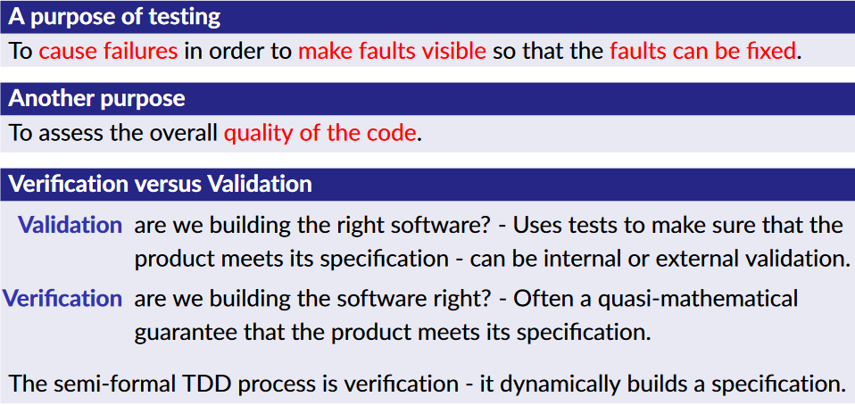

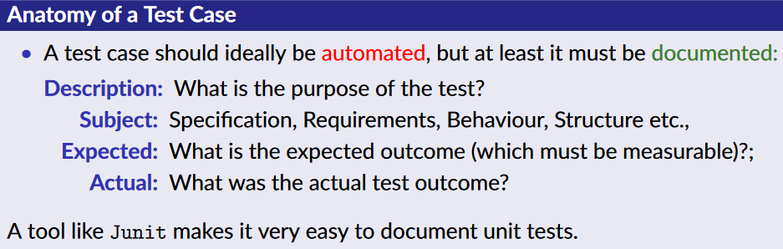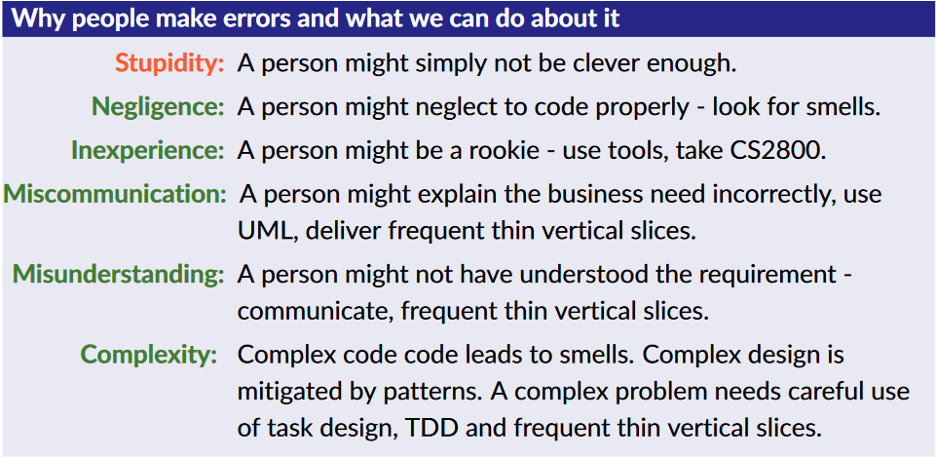

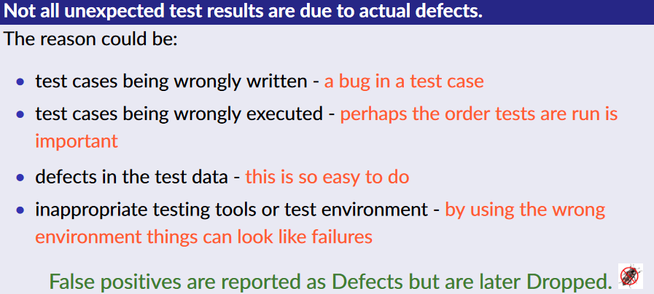

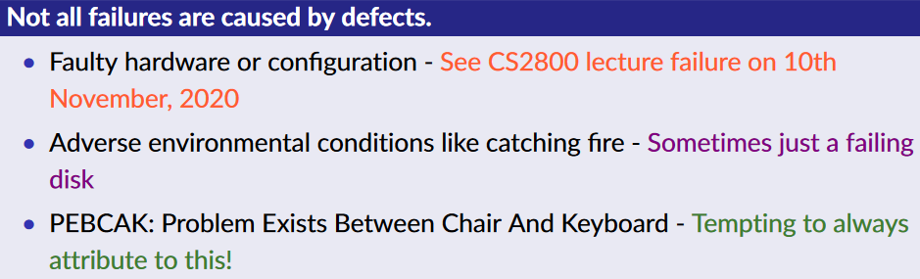

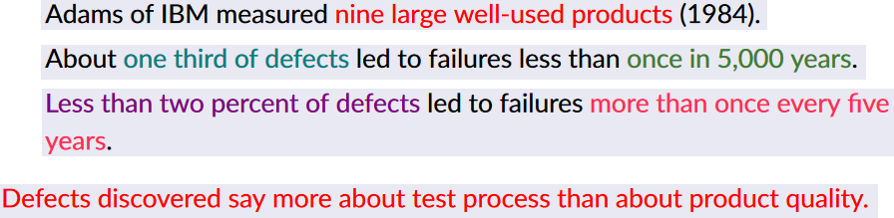

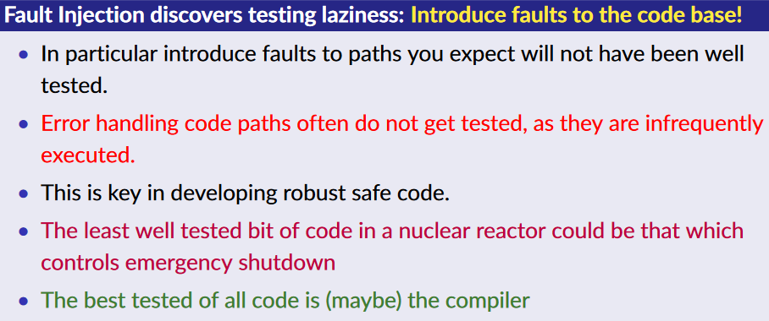

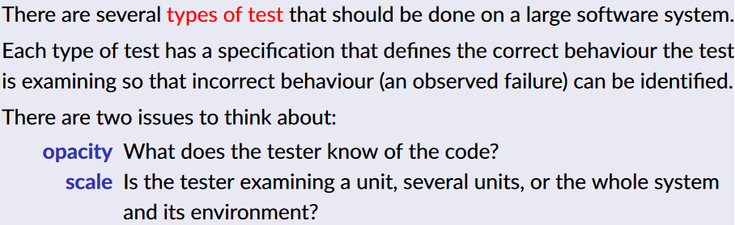

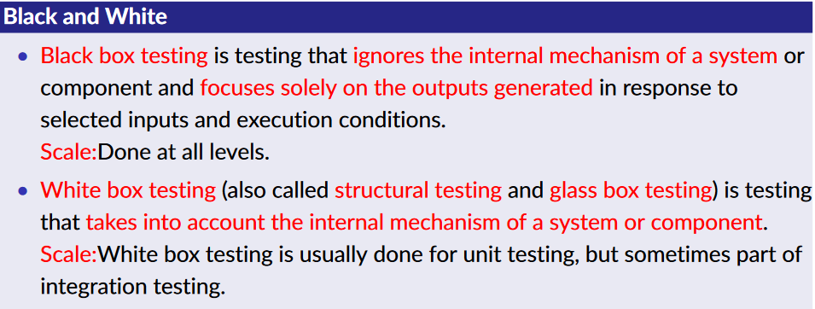

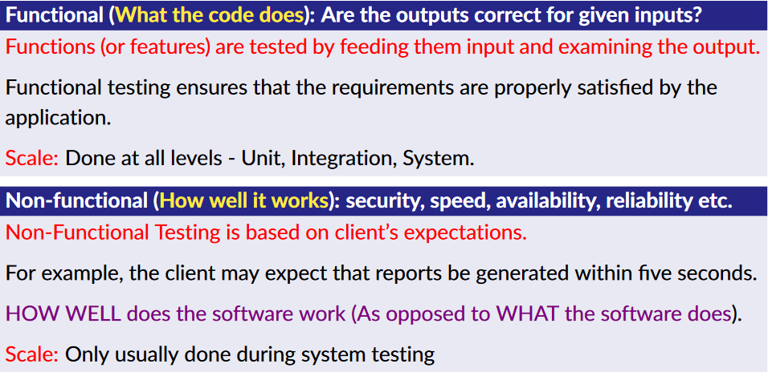

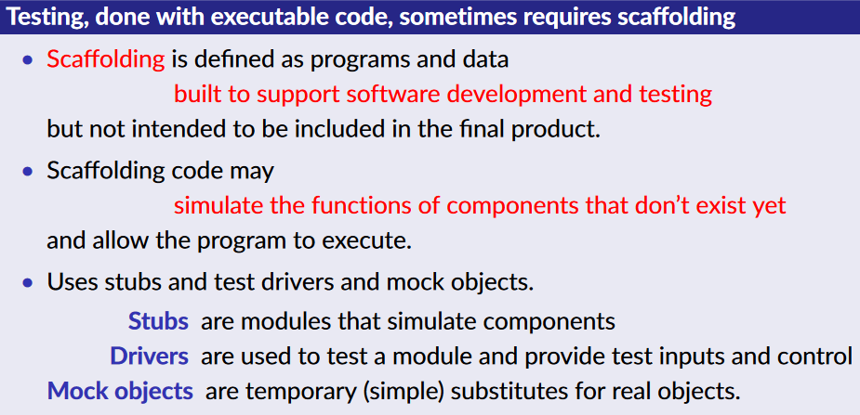

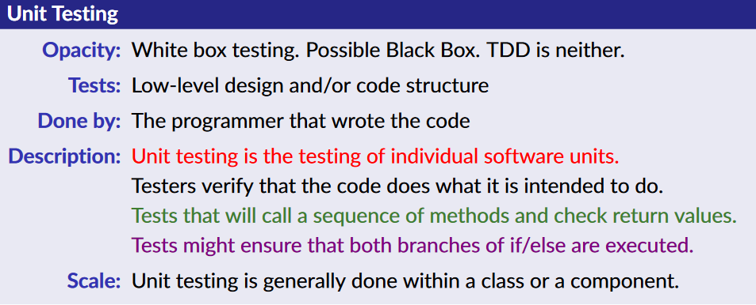

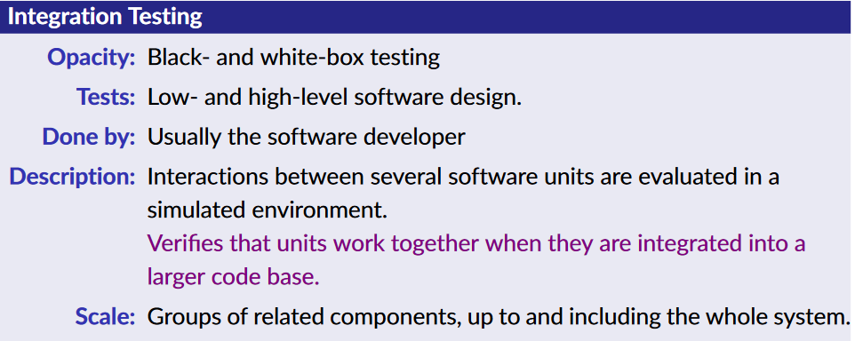





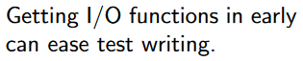

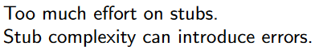

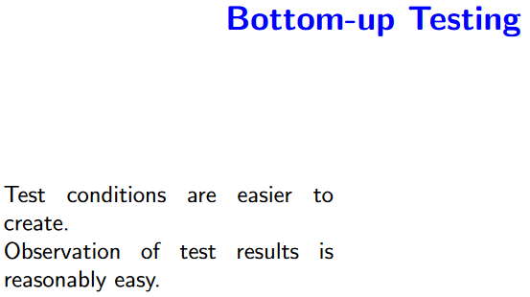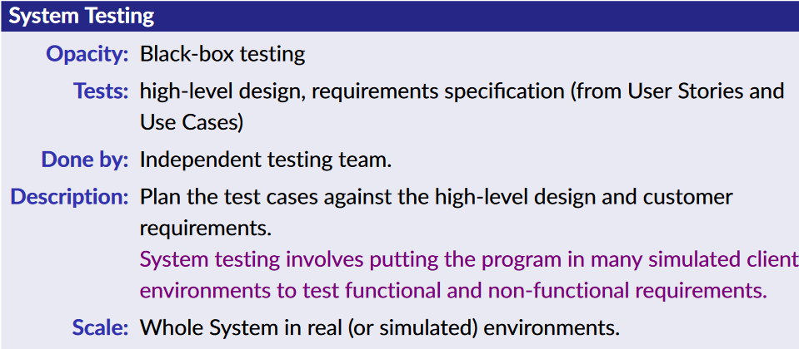

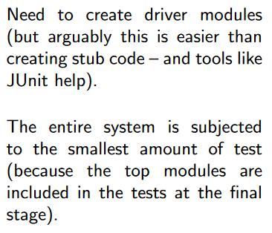

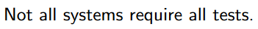

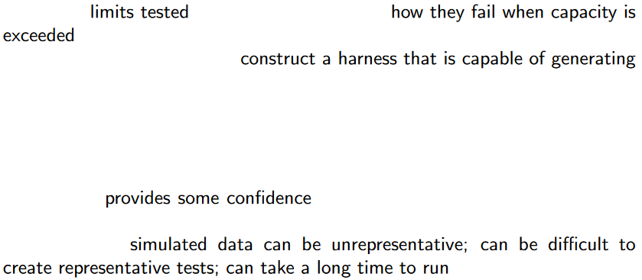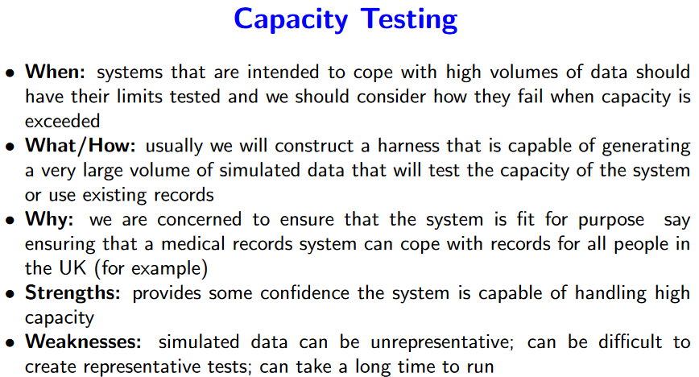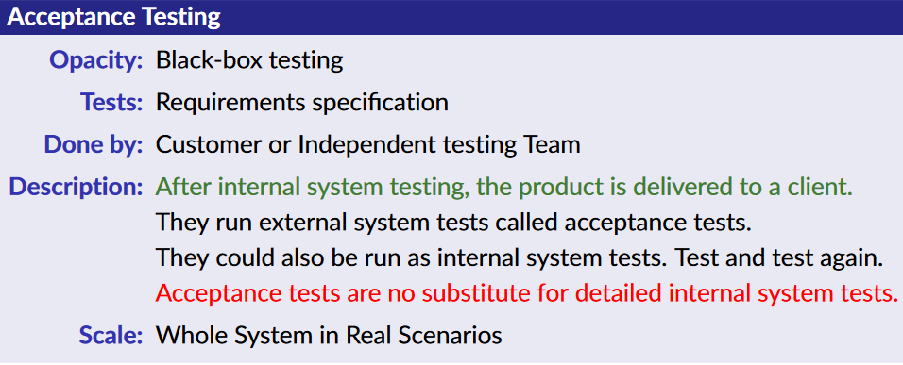





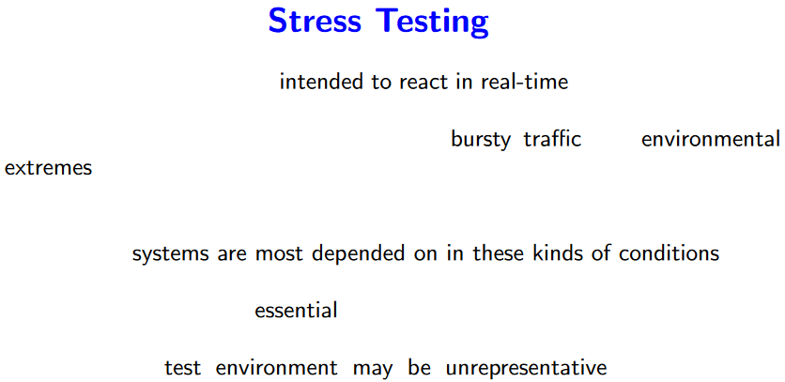



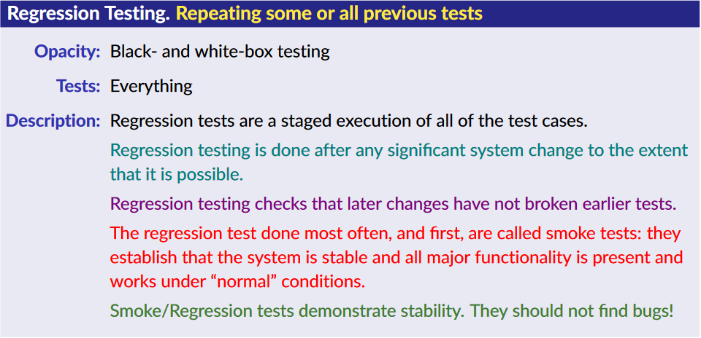

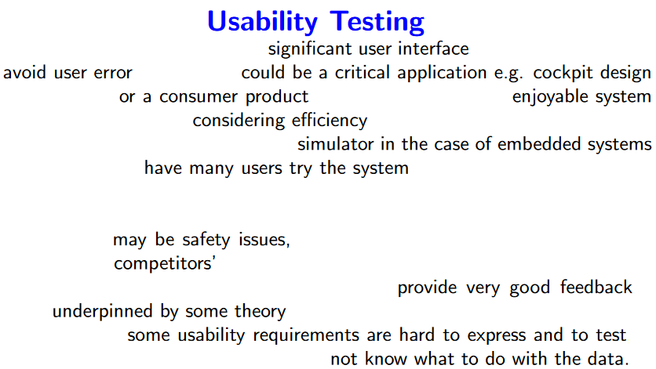











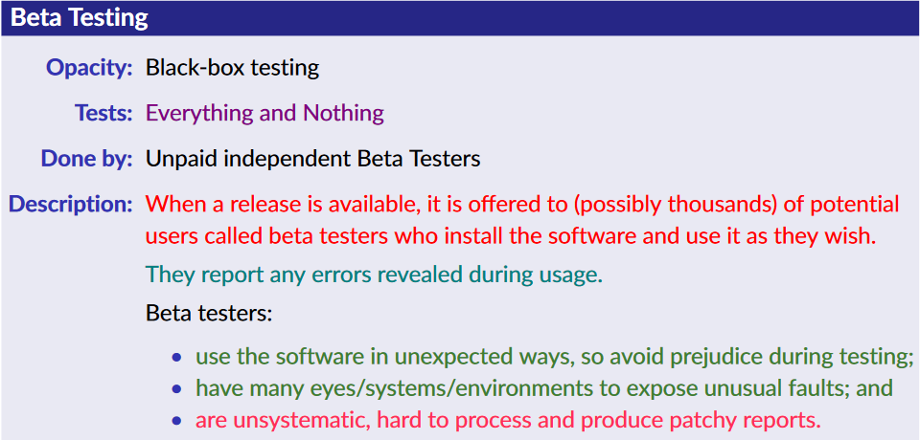





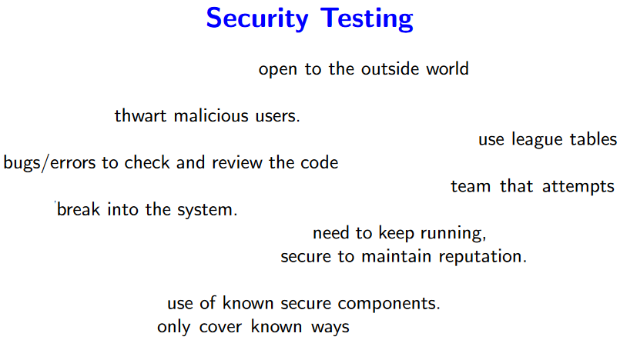







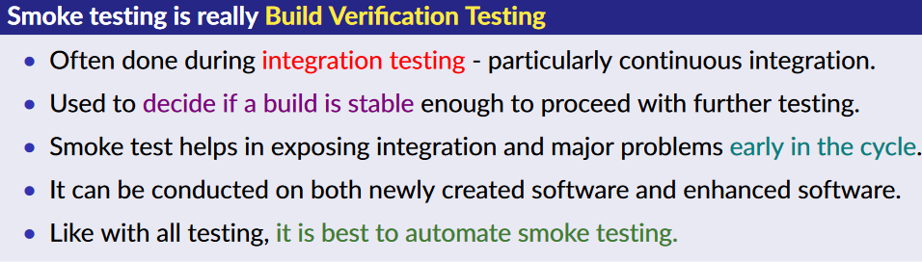



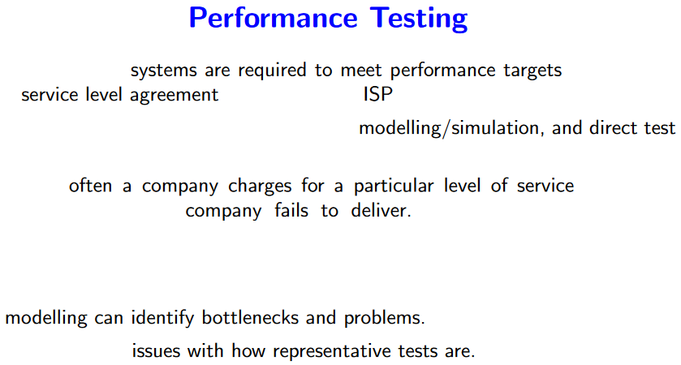





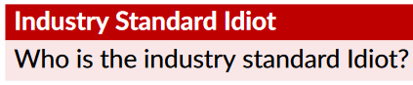

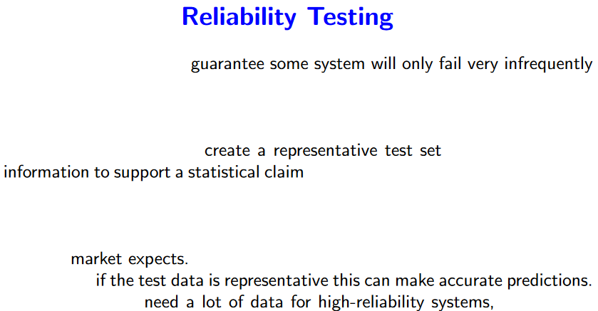





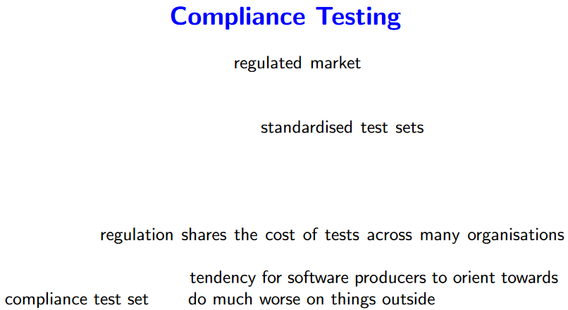



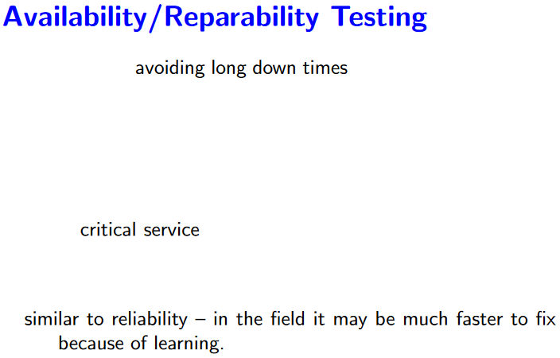

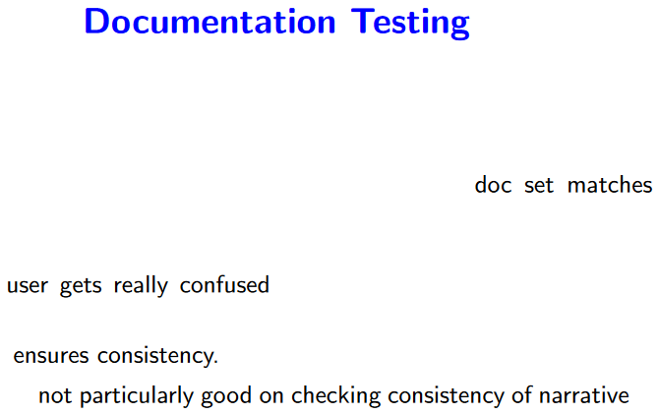

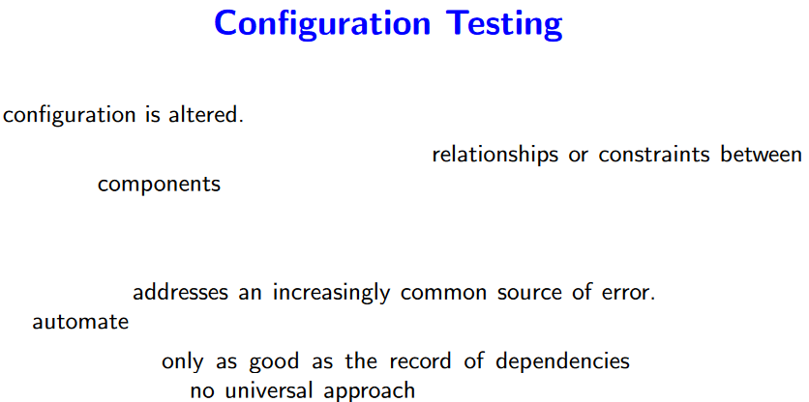





## Communication and Design



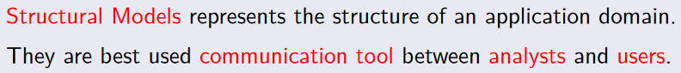

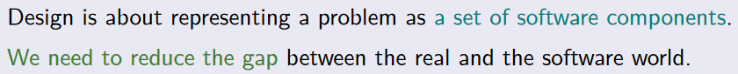

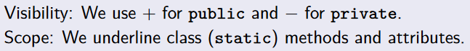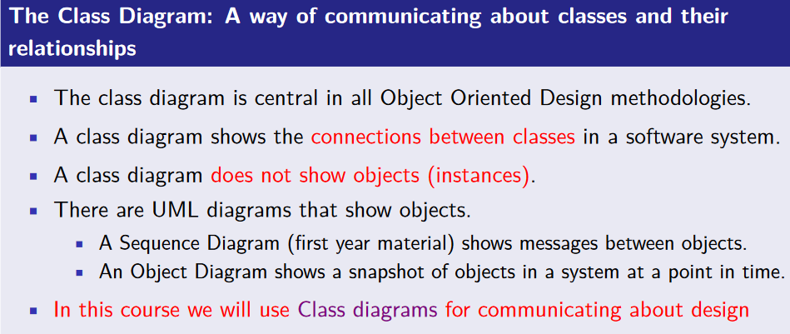

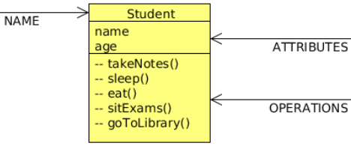

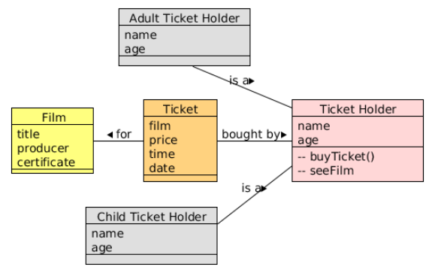



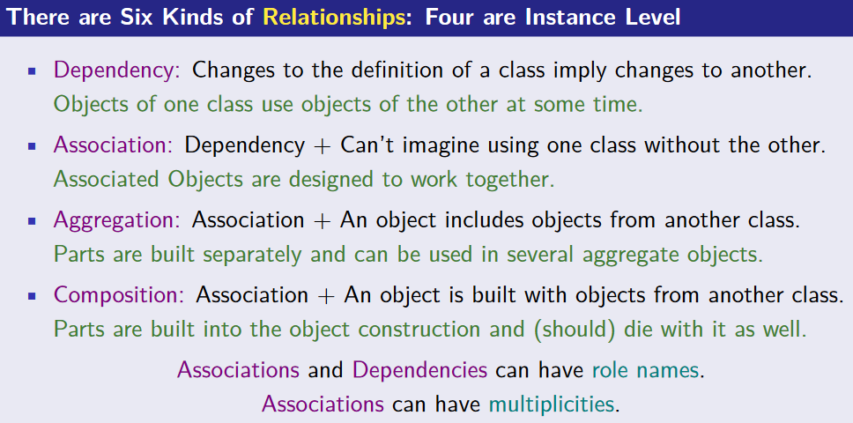

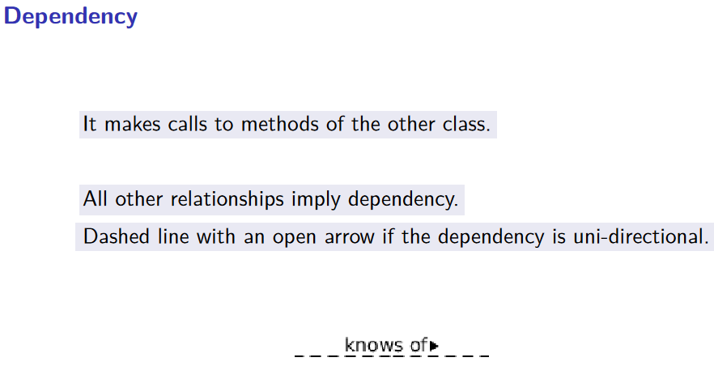



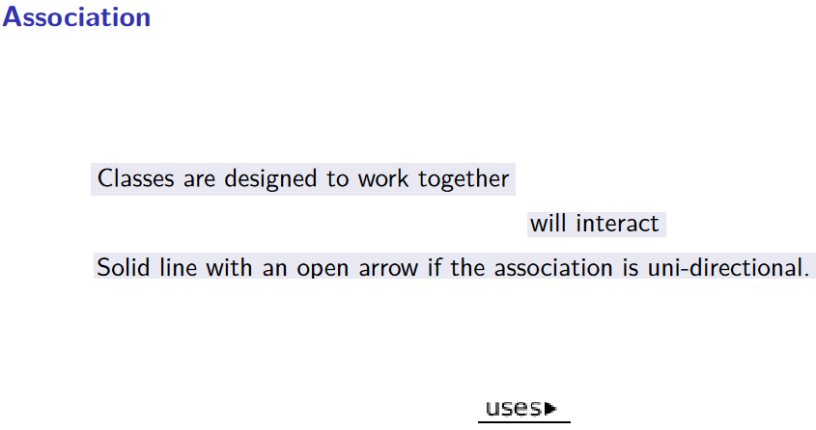

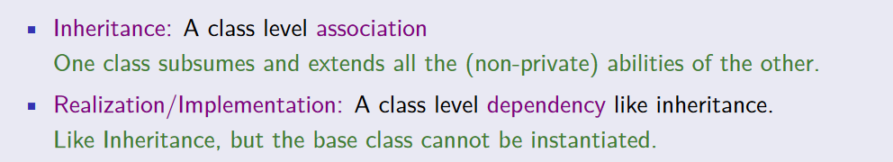

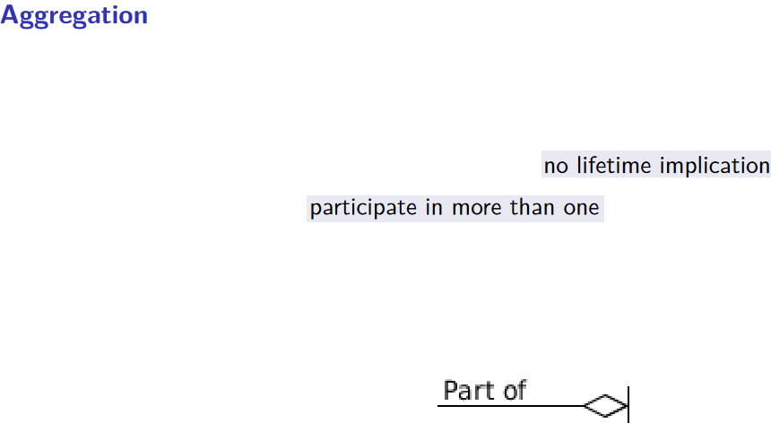



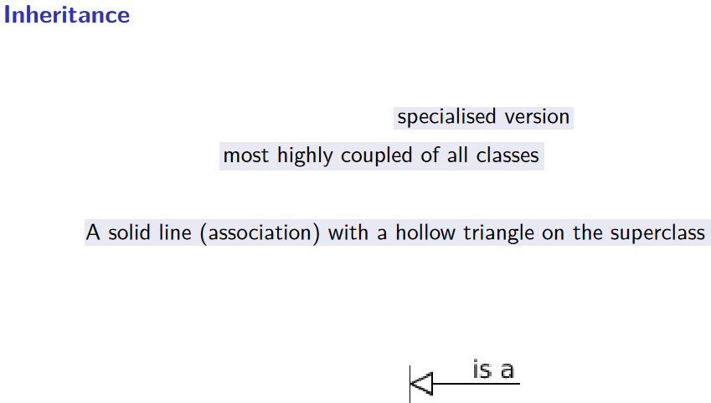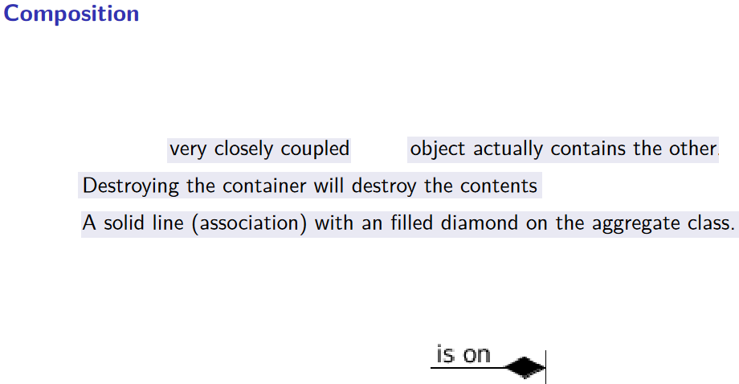





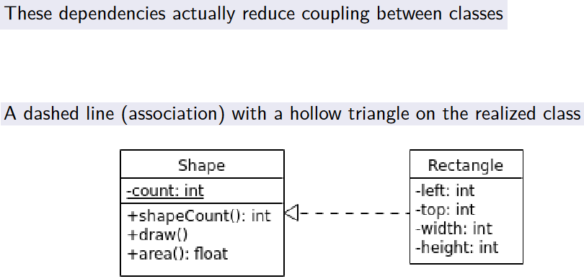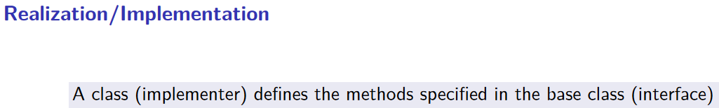

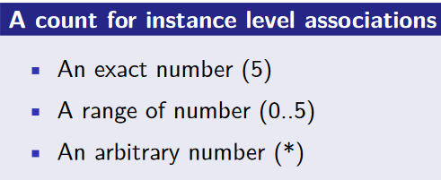



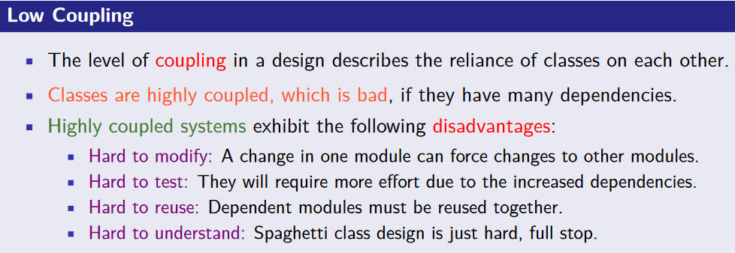

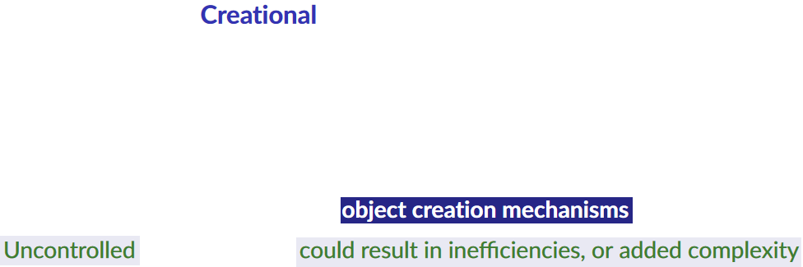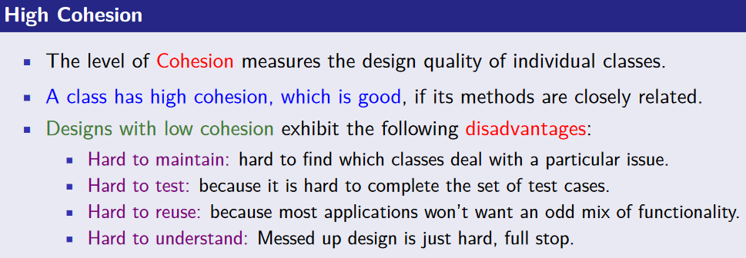



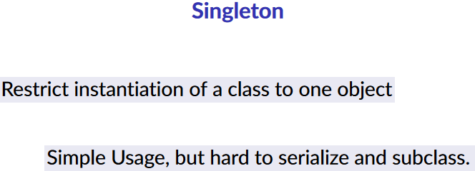



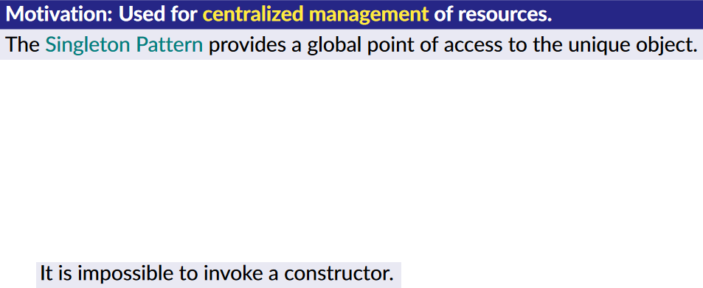

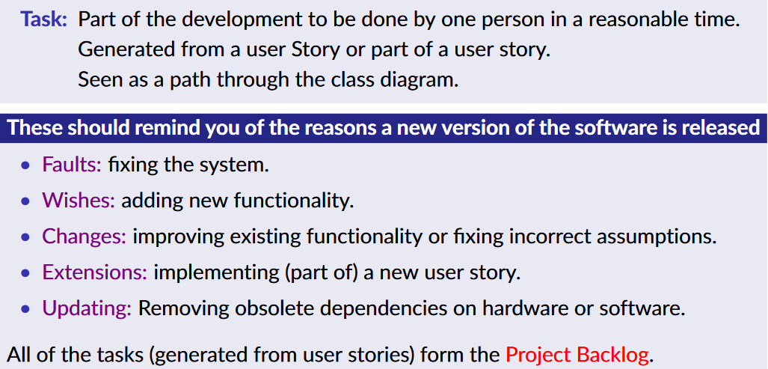

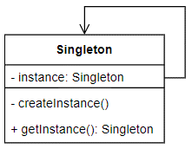

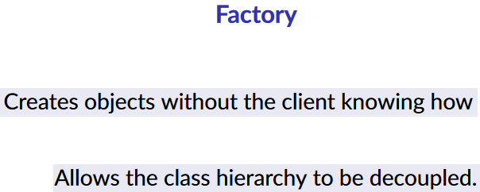



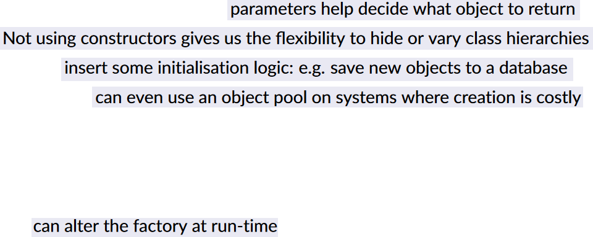



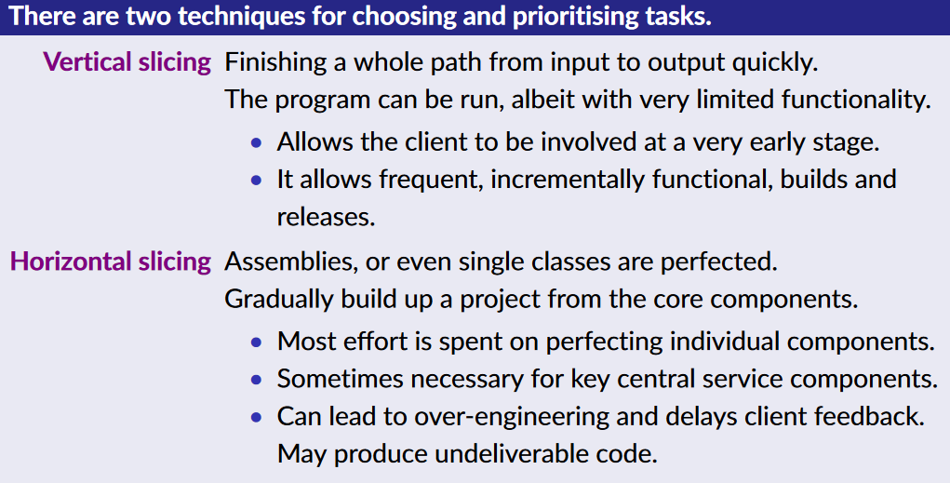





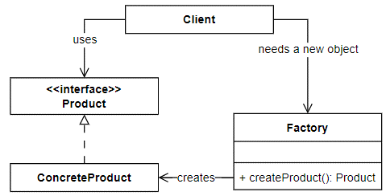

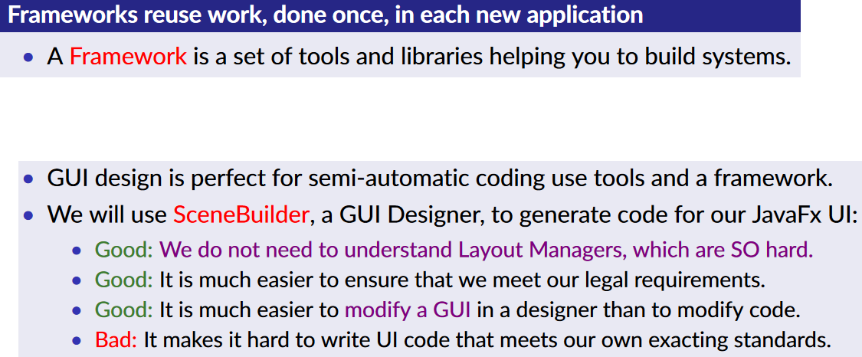



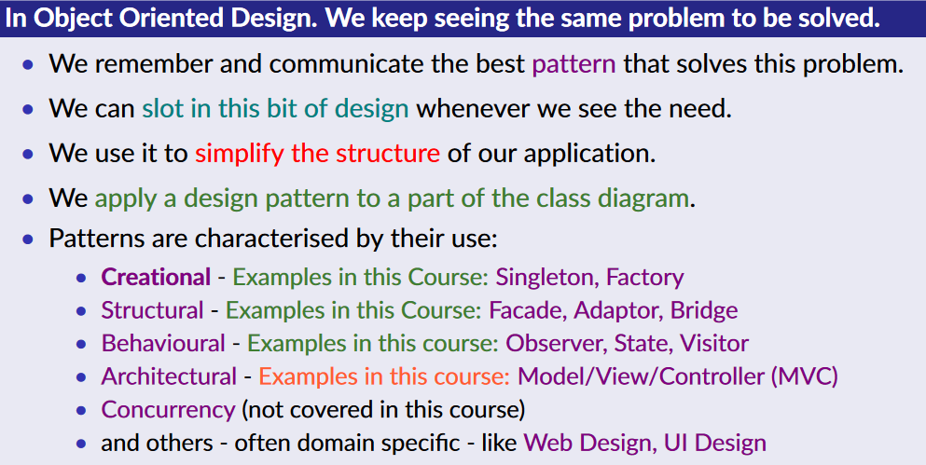



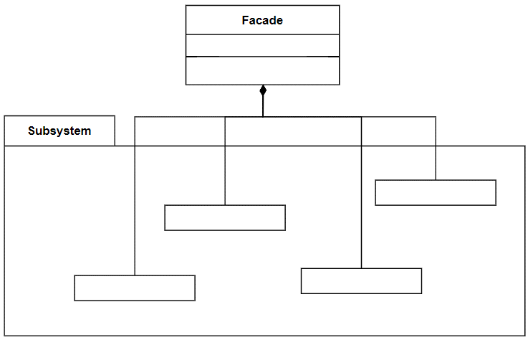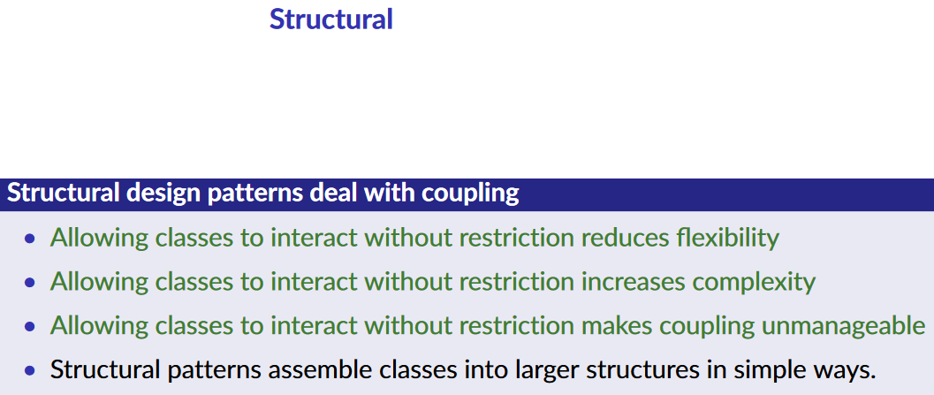

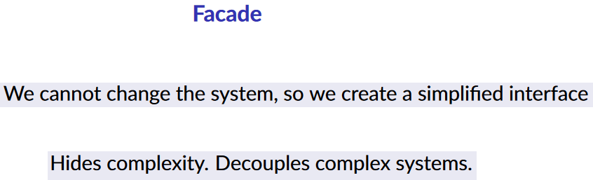



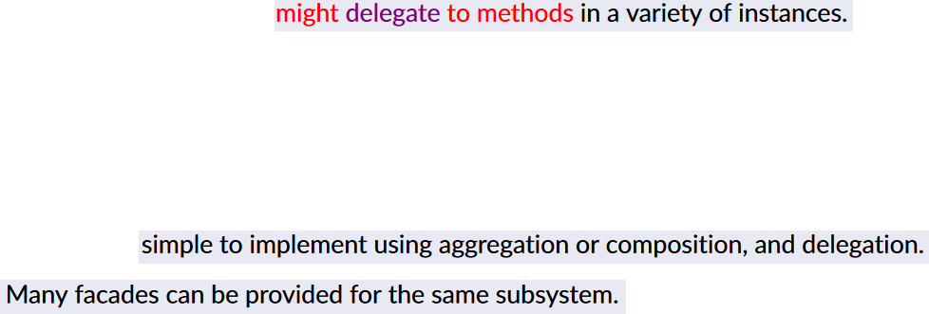

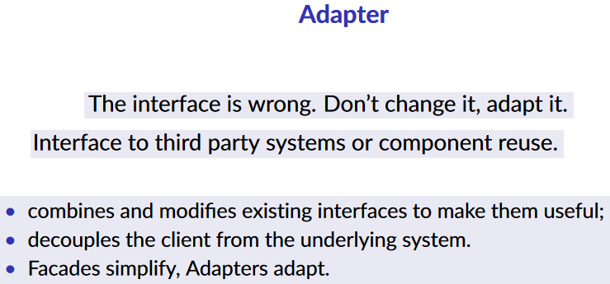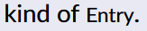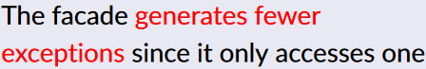



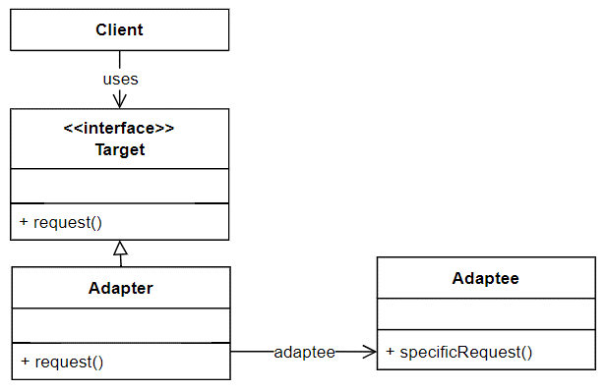

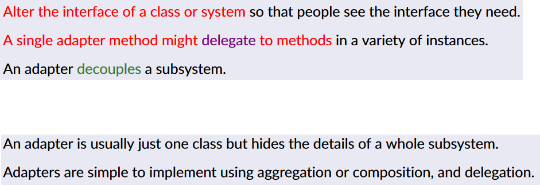



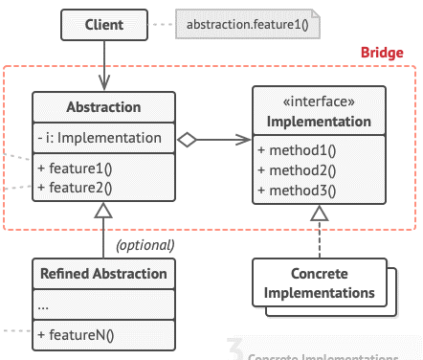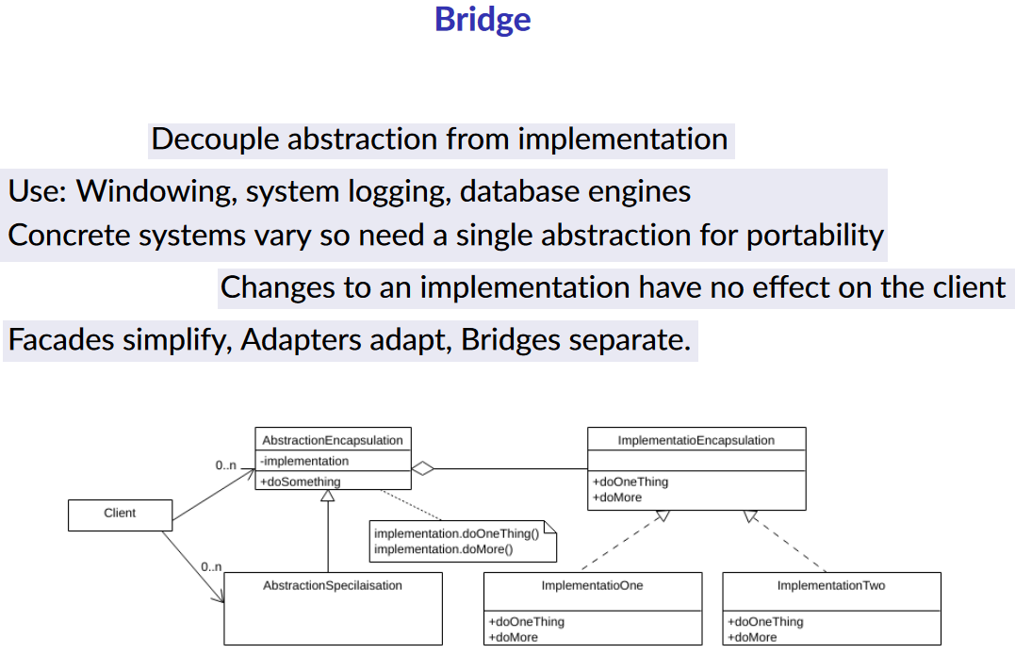





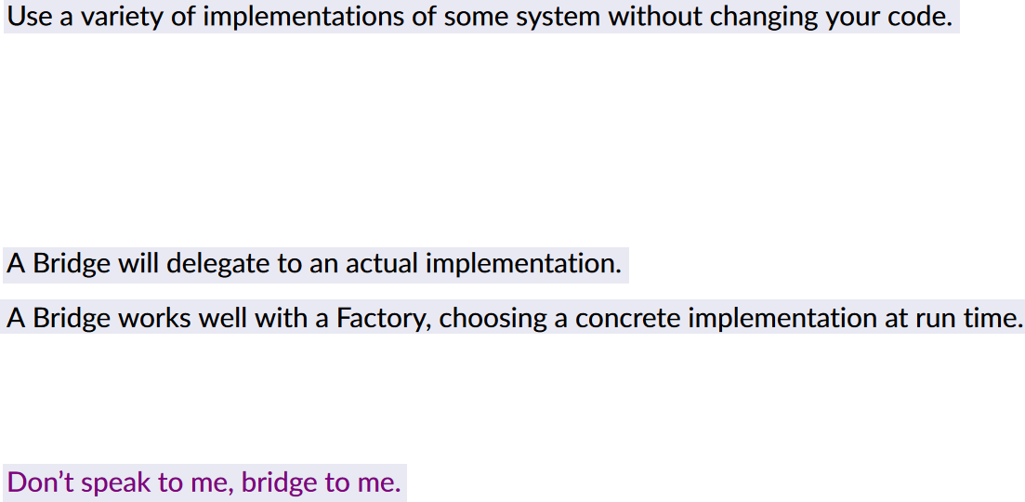







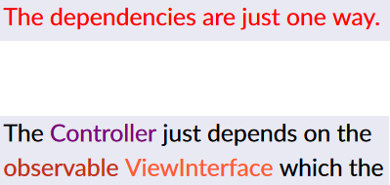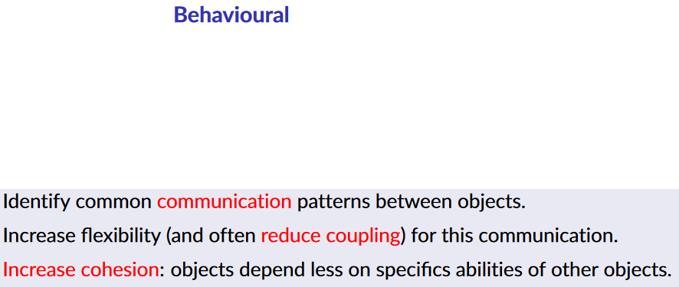



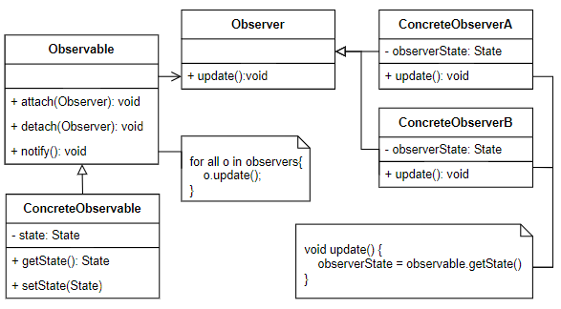

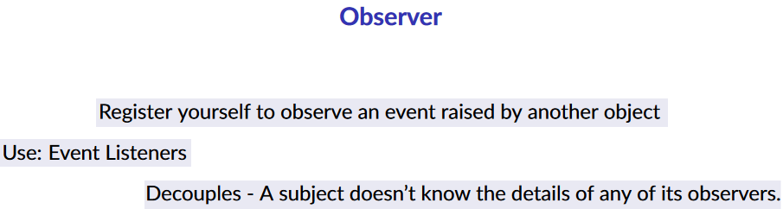

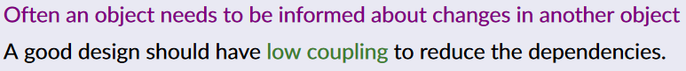

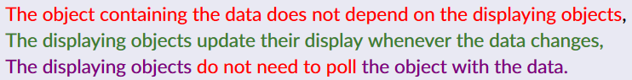

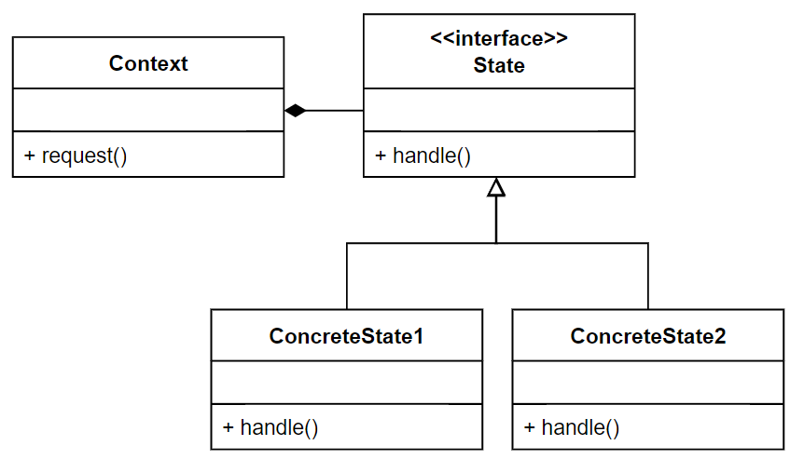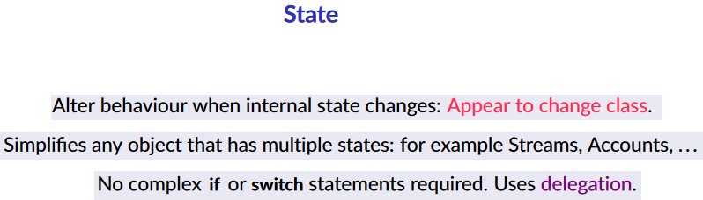

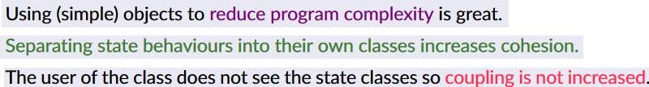

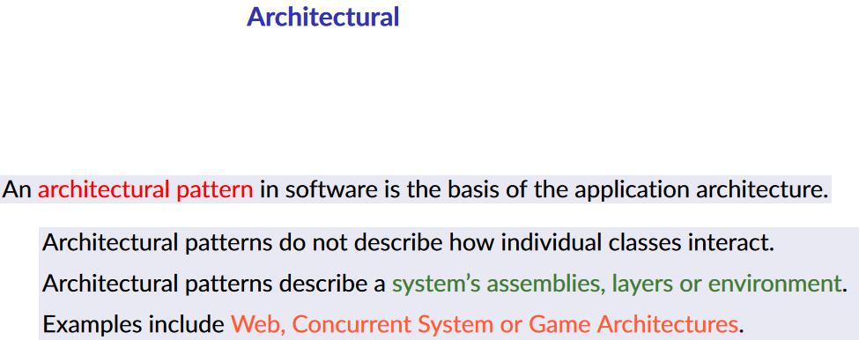



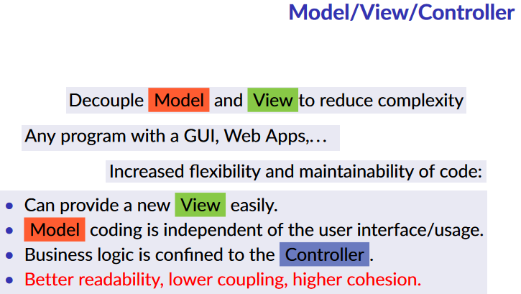



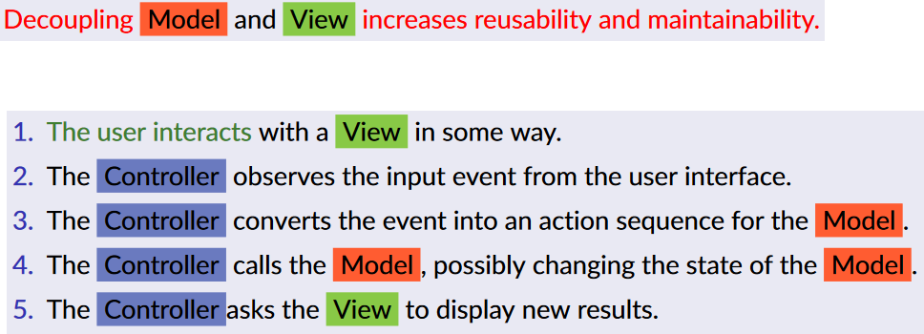

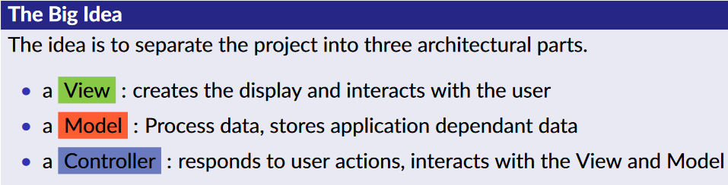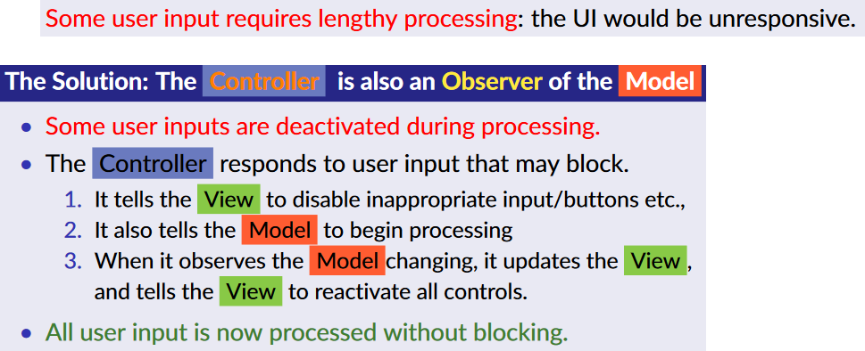



## Tools

CASE tools support the software processes such as requirements engineering, design, program development and testing. CASE tools include design editors, data dictionaries, helpful compilers, debuggers, system building tools, etc. E.g., Javadoc, Context sensitive editors, Symbolic debuggers, Dropbox, Visual editors, Virtual environments, Analyzing Compilers,. . .

Many CASE tools spoil the landscape, so:

• Workbenches integrates CASE tools into one application to support specific software processes.

• Providing a clean interface (presentation integration).

• Allowing easy invocation of tool chains (control integration).

The workbench was okay. Now we have a single glorious tool; an Integrated Project Support Environment integrates tools and views to supports all Software Engineering processes:

• Language sensitive editing (syntax highlighting, formatting)

• Language tools (debugger, builder, execution, packager)

• RAD support (templates, refactoring, documentation)

• Team support (version control, tasks, diagrams)

• Specific process support (unit testing, metrics, standards)

• Project Management and Workflow support (Continuous Integration)

We use;

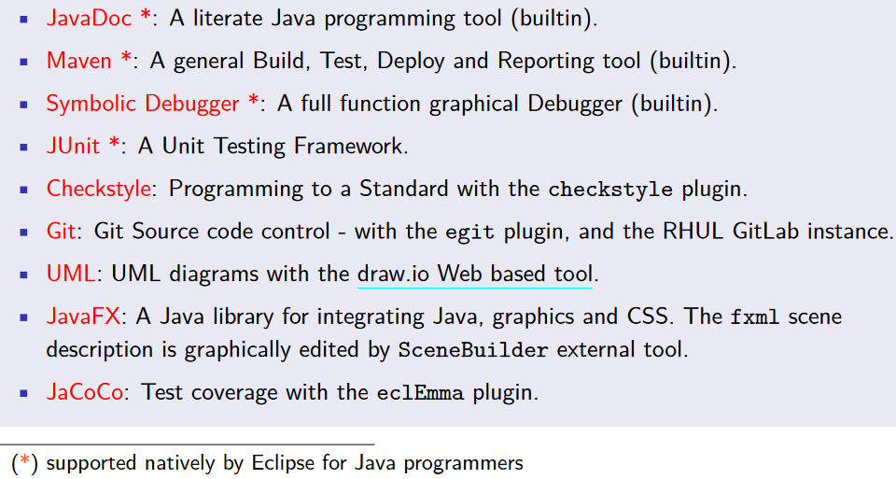

JavaDoc

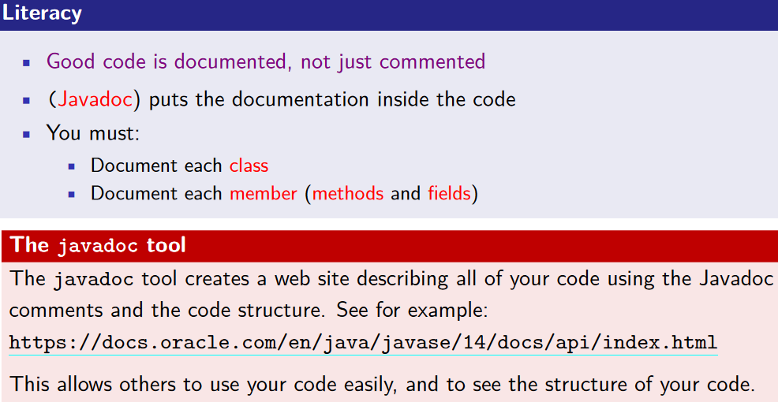

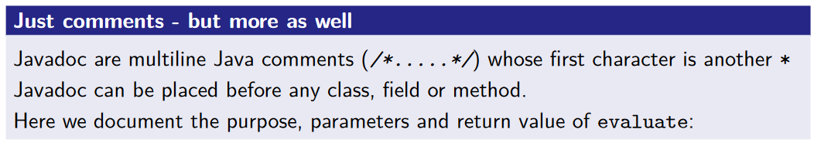

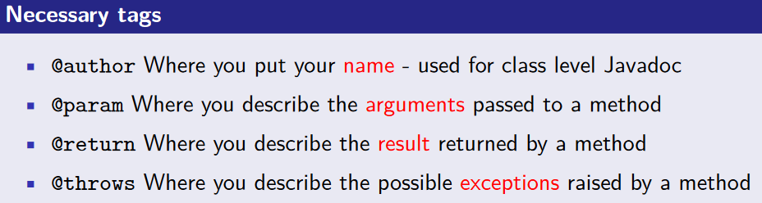

Maven

Maven has a set of lifecycles made up of phases. A phase only gets executed if the previous phase succeeds. Executing a lifecycle attempts to run all its phases from the very first to the last phase. A phase is made up of goals. Goals are achieved by executing code that is contained in a maven plugin.

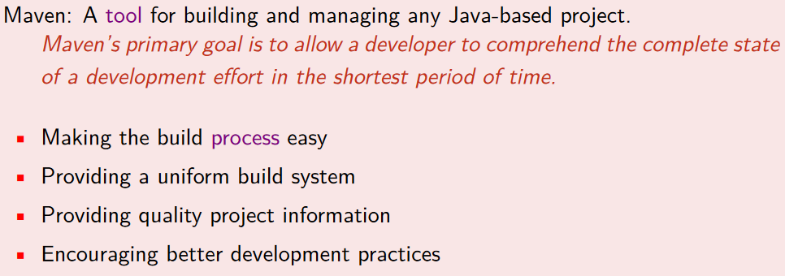

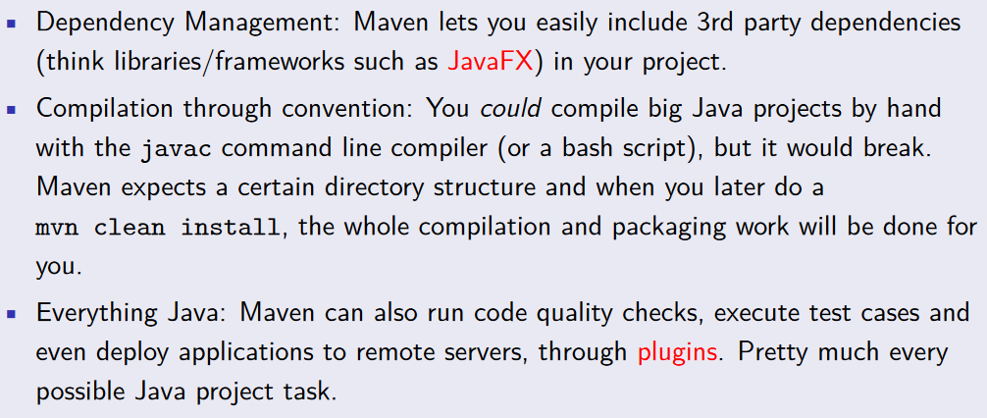

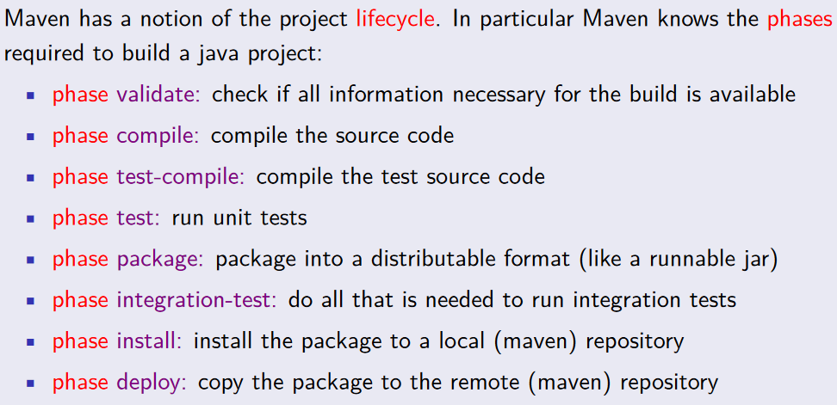

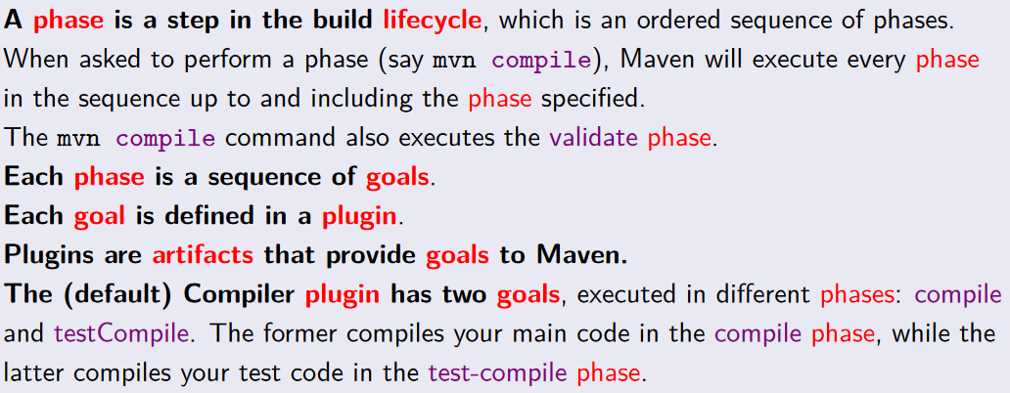

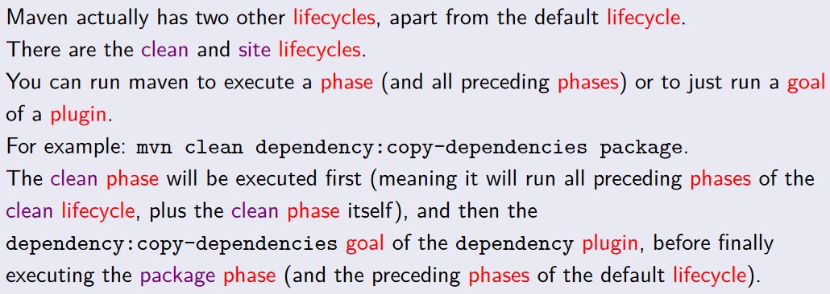

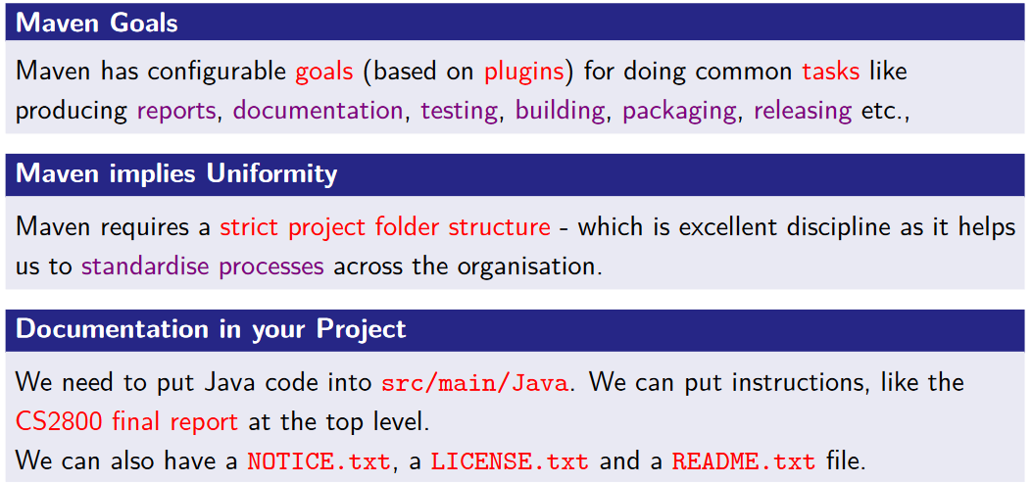

Eclipse (IPSE)

The Eclipse IPSE has a debugger, to help fix bugs in code, and has checkstyle for highlighting code that does not meet the coding standard. Other main features include JavaDoc support, Running and debugging configuration, Package support and other forms of refactoring, Fully configurable build management, Java API support - Eclipse knows the API, Code style support, Export an Eclipse Project or a runnable Jar file, Context sensitive help and Quick Fix support, Diagram editor for class and sequence diagrams and Full version control integration.

* Projects: A collection of Java files in packages, with the test code, MRs, UML diagrams, all in one place.
* Using Maven to manage projects.
* Code Formatting: Use Eclipse indenter and formatter.
* Java Help: Eclipse has full access to all of the help (in context) that you will ever need in Java.
* Navigation: Using Eclipse is not so easy. there are many different perspectives and lots of files and folders.
* Getting the Code Out: Eclipse can package up your program as a runnable Jar file.
* Javadoc: This is a fantastic built in tool (part of the Java language) to allow you to write code that is self-documenting.

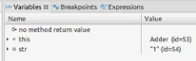Extra stuff: Intelisense, Autofill, creation of classes, fields and methods, suggestions, run configurations, pom management, extensions.

#### A yellow sign with blue text Description automatically generatedThe Debugger

Breakpoints allow you to stop program execution at a certain point so that you can have a look at the values of variables before continuing.

Step through allows you to execute the next line, function, method, or skip them.

JUnit

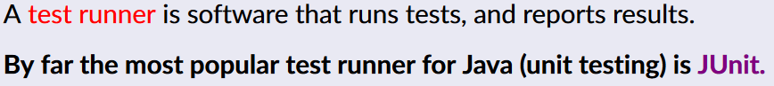Works means passing its unit tests



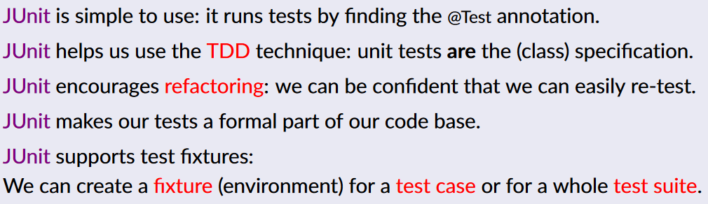

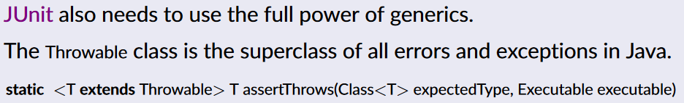

## A diagram of a number of marks Description automatically generatedA close up of a sign Description automatically generatedMeasurement

